Deployment Package
Project Management
Systems Engineering Basic Profile

Notes:
This document is the intellectual propriety of its author’s organization. However, information contained in this document is free of use. The distribution of all or parts of this document is authorized for non commercial use as long as the following legal notice is mentioned:

© International Council on Systems Engineering (INCOSE) 2013

Commercial use of this document is strictly forbidden. This document is distributed in order to enhance exchange of technical and scientific information.
This material is furnished on an “as-is” basis. The author(s) make(s) no warranties of any kind, either expressed or implied, as to any matter including, but not limited to, warranty of fitness for purpose or merchantability, exclusivity, or results obtained from use of the material.
The processes described in this Deployment Package are not intended to preclude or discourage the use of additional processes that Very Small Entities may find useful.

This document is available free of charge at:
http://profs.logti.etsmtl.ca/claporte/English/VSE/index.html
http://www.lero.ie/research/internationalprojects/systemprocessesforsmallenterprises/

Author | Ken Ptack – INCOSE, USA
Editors | Joseph Marvin – INCOSE, USA  Martin Geisreiter – INCOSE, Germany
Creation date | 01/28/13 (Day-Month-year (e.g. 12 June 2012))
Last update | 20 Jan 2014 (Day-Month-year)
Version | 0.2 (X.X)

Version History

Date  (dd/mm/yyyy) | Version | Description | Author
28/01/13 | 0.1 | Initial Release | Ken Ptack
20/01/14 | 0.2 | Revised Release | Ken Ptack
04/07/2014 | 2.0 | Draft DP distribution after IS 2014 | Joe Marvin

Abbreviations/Acronyms

Abre. /Acro. | Definitions
DP | Deployment Package - a set of artefacts developed to facilitate the implementation of a set of practices, of the selected framework, in a Very Small Entity.
IV&V | Integration, Verification, Validation
ISO | International Organization for Standardization, http://www.iso.org
INCOSE | International Council on Systems Engineering, http://www.incose.org/
PM | Project Management
PMBOK | Project Management Body of Knowledge, http://www.pmi.org/
SDD | System Design Document
SEMP | System Engineering Management Plan
SEP | Systems Engineering Plan
SR | System Definition and Realization
SMART | Specific, Measurable, Achievable, Relevant and Traceable
SME | Small and Medium Enterprise
SOW | Statement of Work
VSE | Very Small Entity – an enterprise, organization, department or project having up to 25 people.
VSEs | Very Small Entities
WBS | Work Breakdown Structure

Table of Contents

1. Technical Description 4
Purpose of this document 4
Why is Systems Engineering important? 5
Why is Project Management Important? 6
Why is cooperation between Systems Engineering and Project Management important? 7
2. Definitions 9
Generic Terms 9
Specific Terms 10
3. Relationships with ISO/IEC 29110 12
Role Description 12
4. Description of Processes, Activities, Tasks, Steps, Roles & Products 15
Project Planning Process 16
Project Plan Execution 19
Project Assessment and Control Process 20
Project Closure 21
Product Description 23
Artefact Description 26
5. Template 27
6. Example 30
Example of Project Management Practices Lifecycle 30
7. Checklist 31
Project Plan Review Checklist 31
8. Tool 32
9. Reference to Other Standards and Models 33
ISO 9001 Reference Matrix 33
ISO/IEC 12207 Reference Matrix 33
CMMI Reference Matrix 33
10. References 34
11. Evaluation Form 35

1. Technical Description

Purpose of this document
A deployment package (DP) is a set of artefacts developed to facilitate the implementation of a set of practices in a Very Small Entity (VSE). A DP is not a process reference model (i.e. it is not prescriptive). The elements of a typical DP are: roles and products, description of processes, activities, tasks, template, checklist, reference to standards, etc. This content provides the VSE with essential information regarding the value, which team members should be involved, the process description and specific tasks typically performed by the Work Team to fulfill the function described. Section 4 provides step-by-step instructions for the VSE and may be used as a checklist for executing the functions of the specific DP.

This DP supports the SE Basic Profile as defined in ISO/IEC TR 29110-5-6-2, the Management and Engineering guide [ISO/IEC 29110]. The Basic Profile is one profile of the Generic profile group. The Generic profile group is applicable to VSEs that do not develop critical systems. The Generic profile group is composed of 4 profiles: Entry, Basic, Intermediate and Advanced. The Generic profile group does not imply any specific application domain. The Basic profile is targeted to VSEs working on one project at a time.

The Basic profile is composed of two processes: the Project Management Process and the System Definition and Realization (SR) Process.
The purpose of the Project Management (PM) process is to establish and carry out in a systematic way the Tasks of the system development, which allows complying with the project’s Objectives in the expected quality, time and cost.
The purpose of the System Definition and Realization process is the systematic performance of the analysis, design, construction, integration, verification, and validation activities for new or modified system according to the specified requirements.
Both processes are interrelated (see Figure 1).
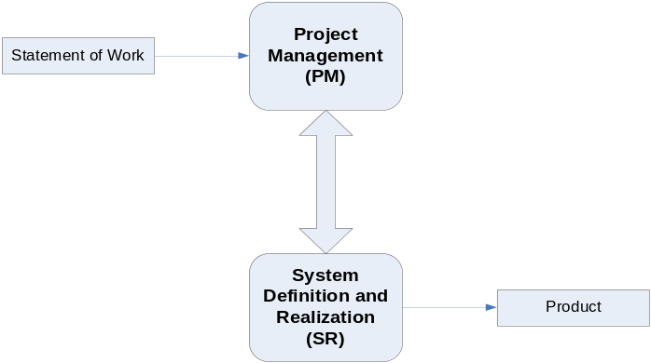
Figure 1 — Basic profile guide processes
The International Council on Systems Engineering (INCOSE) Systems Engineering Handbook has been used as the main source for developing this DP. The INCOSE Handbook is consistent with ISO/IEC 15288:2008 – Systems and software engineering – System life cycle processes.

Information contained in this DP is applicable to VSEs performing general systems engineering functions using conventional Systems Engineering techniques and tools and a Waterfall system life-cycle model. VSEs performing systems engineering in specialized industries and domains (aerospace, atomic energy, medical instrumentation, government, etc.) should be aware of compliance (process objectives, domain-specific requirements and outcomes/artifacts) requirements specific to their area of work. VSEs applying advanced techniques such as Model-Based Systems Engineering (MBSE), Agile or Lean life-cycle models should refer to the Advanced Requirements Engineering DP (to be developed).

The content of this document is entirely informative.

ISO/IEC TR 29110-5-6-2 is available at no cost on the ISO web site at the following URL: http://standards.iso.org/ittf/PubliclyAvailableStandards/index.html

Why is Systems Engineering important?
Modern man-made systems, and system of systems (SoS), continually increase in complexity. These systems are developed, more and more, by partnerships involving multiple suppliers and developers and, very often, geographically dispersed teams. This increase in complexity severely challenges the organization to achieve project success (i.e. delivering the quality expected by the acquirer and stakeholders, on time and within the established budget. In response to the challenge, governments and industry have fostered the development of the Systems Engineering discipline.

INCOSE defines Systems Engineering as:
… an interdisciplinary approach and means to enable the realization of successful systems. It focuses on defining Acquirer needs and required functionality early in the development cycle, documenting requirements, and then proceeding with design synthesis and system validation while considering the complete problem.

Recent research work performed by Eric Honour as demonstrated that:
- There is a quantifiable relationship between Systems Engineering effort levels and program success (i.e. meeting the program schedule and within budget), as shown in the graphs below;
- Systems Engineering has a significant, quantifiable Return on Investment, achieving, optimally, a ROI of 3.5:1;
- There is an optimum amount of Systems Engineering for best program success, representing an “investment” of 14.4% of the total program cost on Systems Engineering activities.

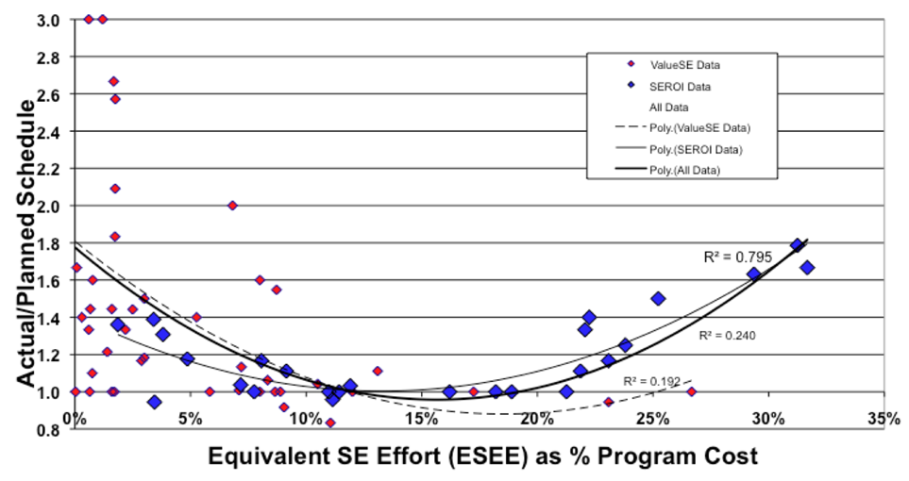

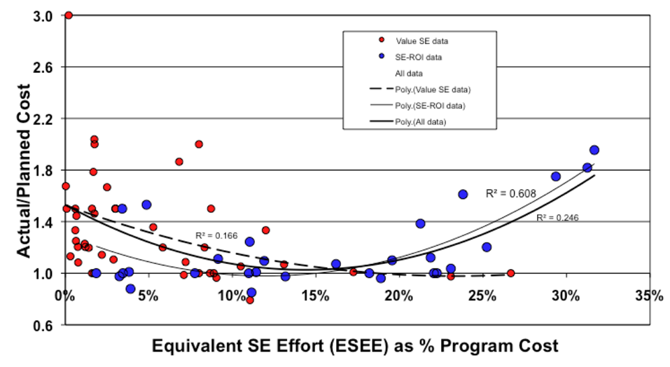

Increasingly, the responsibility to develop complex systems has flowed down through the supply chain to smaller and smaller organizations. It is not surprising, then that Very Small Entities (VSEs) are seeking ways increasingly to achieve program success through the implementation of Systems Engineering best practices.

Why is Project Management Important?

The purpose of the Project Management process is to establish and carry out, in a systematic way, the Tasks of the system development project, which allows complying with the project’s Objectives in the expected quality, time and costs. Many systems fail not because there is no market, but because the cost of creating the system far outstrips any profit. Currently approximately half a million project managers worldwide are responsible for in the region of one million system and software projects each year, which produce products worth USD$600 billion. It is now accepted that many of these projects fail to fulfil acquirers' expectations or fail to deliver the system within budget and on schedule [Jalote02]. Putnam suggests that about one-third of projects have cost and schedule overruns of more than 125% [Putnam97].

Why is cooperation between Systems Engineering and Project Management important?
Systems engineers and program managers bring unique skills and experiences to the programs on which they work. There is also a “shared space” (PM/SE) where program managers and systems engineers collaborate to drive the program team’s performance and success. Therefore they have to collaborate.
Figure 1 shows a concept how systems engineering (SE) and project management (PM) might relate to each other. The basis for this concept is the project lifecycle as proposed by ISO 21500 – Guidance on project management. But it’s too simple just to consider the pure project time span for a product development. SE has to consider the whole life cycle of a product in the product concepts until product disposal. Therefore SE has to contribute in all project control activities and provide relevant inputs.

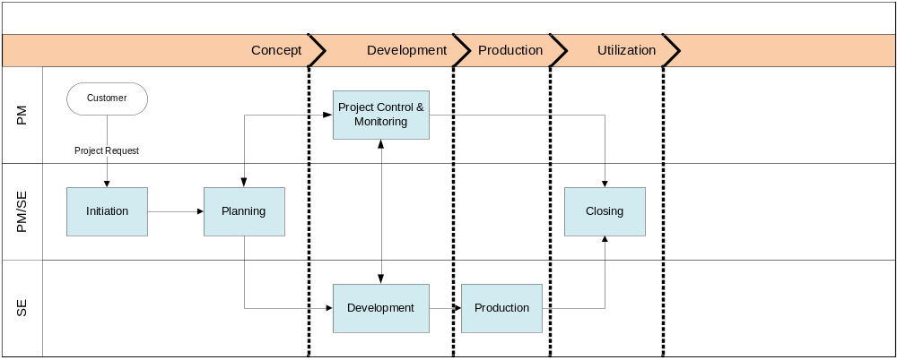
Figure 1 Overview of a concept for SE – PM cooperation

A DP is not a complete process reference model; therefore, a VSE may need guidance on how they might perform a project. To facilitate this, the ISO/IEC TR 29110 simplified technical processes have been defined (see the 9 coloured blocks in Figure 2). Each of these blocks consists of business aspects and technical aspects which change the degree of PM and SE involvement respectively. Interface management or requirements engineering are commonly understood as being SE activities, but they are also influenced by business aspects, enterprise interests, or simply by available resources which are more in the PM domain. Therefore the addressed technical processes in Figure 2 might be understood as common (PM&SE) activities.
Configuration management (CM) might be understood as an enterprise oriented task and used in every project. The activities of CM should start with the earliest project activities (the first idea for a project) and will not end with project completion. The stored information must be available after a project is finished for several purposes (e.g. follow-on project, legal issues, etc.).
Each of the technical process blocks includes activities which might be performed in different project phases. Figure 2 shows an example to map project process steps to single technical processes. The details for the technical processes are described in the different DPs.

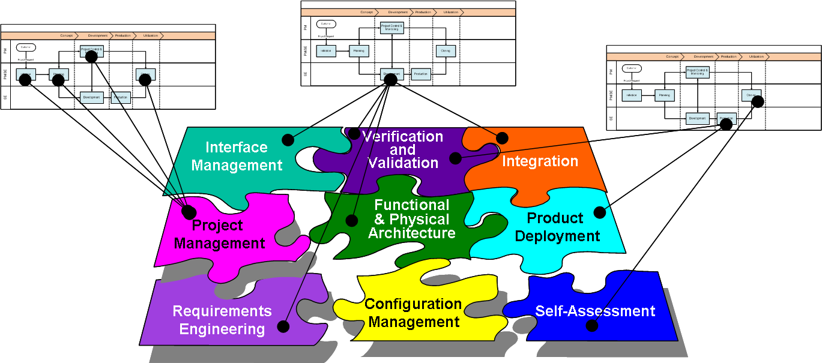
Figure 2 DP structure and linkage to project steps

2. Definitions

In this section, the reader will find two sets of definitions. The first set defines the terms used in all Deployment Packages, i.e. generic terms. The second set of terms used in this Deployment package, i.e. specific terms.

Generic Terms

Acquirer: the stakeholder that acquires or procures a product or service from a supplier. [ISO/IEC 15288]
NOTE: Other terms commonly used for an acquirer are buyer, customer, owner, or purchaser.

Activity: a set of cohesive tasks of a process [ISO/IEC 15288].

Process: a set of interrelated or interacting activities which transform inputs into outputs [ISO 9000:2005]

Product: the result of a process [ISO 9000:2005]

Project: an endeavour with defined start and finish criteria undertaken to create a product or service in accordance with specified resources and requirements [ISO/IEC 15288]

Role: a defined function to be performed by a project team member, such as testing, filing, inspecting, coding. [ISO/IEC 24765]

Step: In a deployment package, a task is decomposed in a sequence of steps.

System: combination of interacting elements organized to achieve one or more stated purposes [ISO/IEC 15288]
NOTE 1 A system may be considered as a product or as the services it provides.
NOTE 2 In practice, the interpretation of its meaning is frequently clarified by the use of an associative noun, e.g. aircraft system. Alternatively, the word “system” may be substituted simply by a context-dependent synonym, e.g., aircraft, though this may then obscure a system principles perspective.

System element: a member of a set of elements that constitutes a system [ISO/IEC 15288]
NOTE A system element is a discrete part of a system that can be implemented to fulfil specified requirements. A system element can be hardware, software, data, humans, processes (e.g. processes for providing service to users), procedures (e.g. operator instructions), facilities, materials, and naturally occurring entities (e.g. water, organisums, minerals), or any combination.

Systems engineering (SE): an interdisciplinary approach and means to enable the realization of successful systems. [ISO/IEC DTR 16337]

Task: a requirement, recommendation, or permissible action, intended to contribute to the achievement of one or more outcomes of a process [ISO/IEC 15288].

Specific Terms

Disposed system: a system that has been transformed (i.e., state change) by applying the disposal process.
NOTE: A systems approach considers the total system and the total life cycle of the system. This includes all aspects of the system and the system throughout its life until the day users depose of the system and the external enterprises complete the handling of the disposed system products.
Adapted from [ISO/IEC/IEEE 15288: 2008]

Resource: an asset that is utilized or consumed during the execution of a process [ISO/IEC 15288]

Stakeholder: an individual or organization having a right, share, claim, or interest in a system or in its possession of characteristics that meet their needs and expectations [ISO/IEC 15288]

Statement of work (SOW): the document used by the acquirer that includes the needs and expectations, the scope, objectives and deliverables [ISO/IEC/IEEE 12207:2008]
Systems Engineering Plan (SEP): top‐level plan for managing the SE effort and, as such, defines how the project will be organized, structured, and conducted and how the total engineering process will be controlled to provide a product that satisfies stakeholder requirements.
NOTE: also called Systems Engineering Management Plan (SEMP)
[INCOSE: 2010]

System structure: the decomposition of a system of interest into a set of interacting systems and system elements
NOTE The system structure is described in a System Breakdown Structure (SBS).
[ISO/IEC/IEEE 15288:2008]

Supplier: an organization or an individual that enters into an agreement with the acquirer for the supply of a product or service [ISO/IEC 15288]
NOTE 1 Other terms commonly used for supplier are contractor, producer, seller or vendor.
NOTE 2 The acquirer and the supplier may be part of the same organization.

Trade-off: decision-making actions that select from various requirements and alternative solutions on the basis of net benefit to the stakeholders
[ISO/IEC/IEEE 15288:2008]

Work Breakdown Structure (WBS): [Output/Input] a deliverable-oriented hierarchical decomposition of the work to be executed by the project team to accomplish the project objectives and create the required deliverables. It organizes and defines the total scope of the project.
[ISO/IEC/IEEE 24765:2010]

3. Relationships with ISO/IEC 29110

This DP covers the activities related to Project Management of the ISO Technical Report ISO/IEC 29110 5-6-2 for Very Small Entities (VSEs) – Basic Profile [ISO/IEC29110].
This DP is intended to be used by the VSE to establish processes to implement any development approach or methodology including, e.g., agile, evolutionary, incremental, test driven development, etc. based on the VSE organization or project needs.

In this section, the reader will find a list of Project Management (PM) processes, activities, tasks and roles that are directly related. This topic is described in details in the next section. The Task List will help the Project Manager scope and plan the System Project Management effort.

Role Description
This is an alphabetical list of the roles, abbreviations and list of competencies as defined in ISO/IEC 29110 5-6-2.
 | Role | Abbreviation | Competency
1. | Project Manager | PM | Leadership capability with experience making decisions, planning, personnel management, delegation and supervision, finances and system development.
2. | Technical Leader | TL | Knowledge and experience in the system development and maintenance.
3. | Work Team | WT | Knowledge and experience according to their roles on the project: SE, Engineer, Specialty Engineering, etc.
4 | Acquirer | ACQ | Knowledge of the Acquirer processes and ability to explain the Acquirer requirements.  The Acquirer (representative) must have the authority to approve the requirements and their changes.  The Acquirer includes user representatives in order to ensure that the operational environment is addressed.  Knowledge and experience in the application domain.

- Process: 4.2 Project Management Process (PM)
- Activity: PM1 Project Planning
- Tasks and Roles:
Tasks | Roles
PM.1.1 Review the Statement of Work | PM, TL
PM.1.2 Define with the Acquirer the Delivery Instructions of each one of the deliverables specified in the Statement of Work. | PM, ACQ
PM.1.3 Define the System Breakdown Structure that represents the relationship between the system and its system elements. | PM, WT
PM.1.4 Identify the specific Tasks to be performed in order to produce the Deliverables and their System Elements identified in the Statement of Work. Include Tasks in the SY process along with verification, validation and reviews with Acquirer/other stakeholders and Work Team Tasks to assure the quality of work products. Identify the Tasks to perform the Delivery Instructions. Document the Tasks. | PM, TL
PM.1.5 Establish the Estimated Duration to perform each task. | PM, TL
PM.1.6 Identify and document the Resources: human, material, equipment and tools, standards, including the required training of the Work Team to perform the project. Include in the schedule the dates when Resources and training will be needed. | PM, TL
PM.1.7 Establish the Composition of Work Team assigning roles and responsibilities according to the Resources. | PM, TL
PM.1.8 Assign estimated start and completion dates to each one of the Tasks in order to create the Schedule of the Project Tasks taking into account the assigned Resources, sequence and dependency of the Tasks. | PM, TL
PM.1.9 Calculate and document the project Estimated Effort and Cost. | PM,
PM.1.10 Identify and document a Risk Management Approach and the risks which may affect the project. | PM, TL
PM.1.11 Identify and document a Disposal Management Approach. | PM. TL
PM.1.12 Document the Configuration Management Strategy in the Project Plan. | PM, TL
PM.1.13 Generate the Project Plan integrating the elements previously identified and documented. | PM
PM.1.14 Include Product Description, Scope, Objectives and Deliverables in the Project Plan. | PM, TL
PM.1.15 Verify and obtain approval of the Project Plan.  Verify that all Project Plan elements are viable and consistent. The results found are documented in a Verification Results and corrections are made until the document is approved by PM. | PM, TL
PM.1.16 Review and accept the Project Plan.  Acquirer and other Stakeholders review and accept the Project Plan, making sure that the Project Plan elements match with the Statement of Work. | PM, ACQ,
PM.1.17 Establish the Project Repository using the Configuration Management Strategy. | PM, TL

- Process: 4.2 Project Management Process
- Activity: PM.2 Project Plan Execution
- Tasks and Roles:
Task | Roles
PM.2.1 Review the Project Plan and record actual data in Progress Status Record. | PM, TL, WT
PM.2.2 Analyze and evaluate the Change Request for cost, schedule and technical impact, and include the accepted changes in the Project Plan. | PM, TL
PM.2.3 Conduct revision meetings with the Work Team, review risk status, record agreements and track them to closure. | PM, TL
PM.2.4 Conduct revision meetings with the Acquirer, record agreements and track them to closure. | PM, ACQ, TL, WT
PM.2.5 Perform backup according to the Version Control Strategy. | PM
PM.2.6 Perform Project Repository recovery using the Project Repository Backup, if necessary. | PM

- Process: 4.2 Project Management Process
- Activity: PM.3 Project assessment and control
- Tasks and Roles:
Task | Roles
PM.3.1 Evaluate project progress with respect to the Project Plan | PM, TL, WT
PM.3.2 Establish actions to correct deviations or problems and identified risks concerning the accomplishment of the plan, as needed, document them in Correction Register and track them to closure. | PM, TL, WT
PM.3.3 Identify changes to requirements and/or Project Plan to address major deviations, potential risks or problems concerning the accomplishment of the plan, document them in Change Request and track them to closure. | PM, TL, WT

- Process: 4.2 Project Management Process
- Activity: PM.4 Project closure
- Tasks and Roles:
Task | Roles
PM.4.1. Formalize the completion of the project according to the Delivery Instructions established in the Project Plan, providing acceptance support and getting the Acceptance Record signed. | PM, ACQ
PM.4.2 Update Project Repository. | PM

4. Description of Processes, Activities, Tasks, Steps, Roles & Products

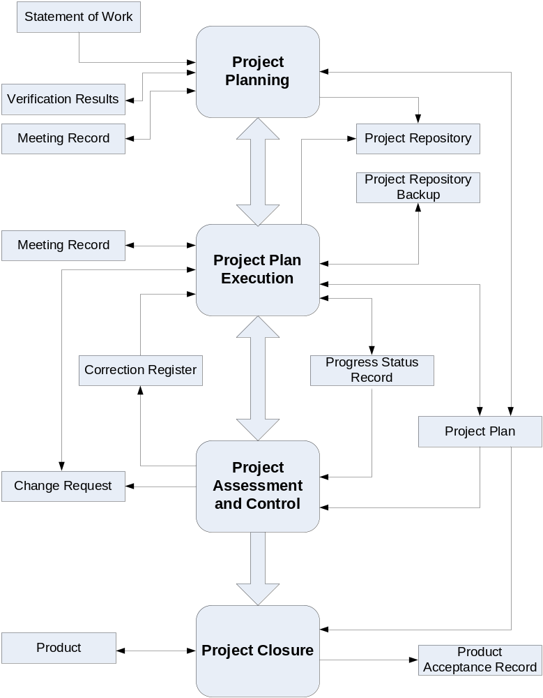

Figure 3 Overview of Project Management Practices

Process: 4.2 Project Management Process (PM)
Activity: PM1 Project Planning

Tasks | Roles
PM.1.1 Review the Statement of Work | PM, TL
PM.1.2 Define with the Acquirer the Delivery Instructions of each one of the deliverables specified in the Statement of Work. | PM, ACQ
PM.1.3 Identify the specific tasks to be performed in order to produce the deliverables and their system components identified in the Statement of Work. | PM, TL
PM.1.4 Establish the Estimated Duration to perform each task. | PM, TL
PM.1.5 Identify and document the resources: human, material, equipment and tools, including the required training of the Work Team to perform the project. | PM, TL
PM.1.6 Establish the Composition of Work Team assigning roles and responsibilities according to the Resources. | PM, TL
PM.1.7 Assign estimated start and completion dates to each one of the tasks in order to create the Schedule of the Project Tasks taking into account the assigned resources, sequence and dependency of the tasks. | PM, TL
PM.1.8 Calculate and document the project Estimated Effort and Cost. | PM
PM.1.9 Identify and document the risks which may affect the project. | PM, TL
PM.1.10 Document the Version Control Strategy in the Project Plan. | PM, TL
PM.1.11 Generate the Project Plan or update it. Furthermore, the Project Plan can be updated due to the Change Request made by the Acquirer or arising from the project. | PM
PM.1.12 Include product description, scope, objectives and deliverables in the Project Plan. | PM, TL
PM.1.13 Verification of the Project Plan. Verify that all Project Plan elements are viable and consistent. | PM, TL
PM.1.14 Validation of the Project Plan. Validate that the Project Plan elements definition match with the Statement of Work. | PM, ACQ
PM.1.15 Establish or prepare the project repository using the Version Control Strategy. | PM, TL

Project Planning Process
Objectives: | The primary objective of the Project Planning Process is to produce and communicate effective and workable project plans.  This process determines the scope of the project management and technical activities, identifies process outputs, project tasks and deliverables, establishes schedules for project task conduct, including achievement criteria, and required resources to accomplish project tasks.
Rationale: | Whatever the size of the project, good planning is essential if it is to succeed. Effective system project management depends on thoroughly planning the progress of a project. A plan formulated at the start of a project should act as a driver for the project. The initial plan should be the best possible plan given the available information. It should evolve as the project progresses and better information becomes available.
Roles: | Project Manager
Roles: | Analyst
Roles: | Acquirer
Artefacts: | Project Plan
Artefacts: | Project Description
Steps: | 1. Identify products and activities
Steps: | 2. Create a WBS (work breakdown structure)
Steps: | 3. Estimate resources, effort and duration
Steps: | 4. Create a schedule
Step Description: | Step 1. Identify products and activities:  During this stage the project manager identifies all the products, tasks and activities that need to be completed before the project can be finished. It may be necessary for the project manager to liaise with the acquirer and the analyst to fully understand the objectives of the project and to break down each one into its constituent parts.  Step 2. Create a WBS (Work Breakdown Structure):  The WBS aims to identify all of the projects tasks that need to be completed and organises them in a hierarchal format, where smaller sub-tasks contribute to the completion of a larger task at a higher level.  A typical WBS would consist of:  - Project  - Task  - Sub-Task  - Work Package  - Effort  Once a WBS is complete, project milestones (key deliverables) can be identified and may be used for project tracking.  Tips: Many system packages such as MS Project can structure WBS information and automatically generate useful graphical representations.  Step 3. Estimate resources, effort and duration:  For each task in the WBS the effort and duration should be estimated and the overall resources required to complete the project calculated.  Typically a ‘bottom-up’ approach is used to estimate the effort requires for each task in the WBS in terms of person hours or person days.  In order to create a schedule of tasks and estimate total project budget, it is necessary to estimate the resources (people, equipment, services, etc.) required to complete each task.  Step 4. Create a schedule:  Tasks should be organised into a coherent sequence, including parallel activities, and mapped against time and resources, to produce a schedule of tasks to be completed by individuals during the lifetime of the project.  Communications:  Confirm all previous steps are fully communicated to all parties by:  - Distributing all output reports to all parties, in particular those that must do the tasks, or be influenced by the outcome of the tasks or schedules.  - Holding a meeting(s) with all participants to ensure any queries are raised and actioned, or assigned for action.  Tips:  - When scheduling task execution ensure the percentage of time each participant has to allocate to the project is taken into account, thus if the task should take 3 days full time and the task owner can only allocate one day a week then the task duration will take 15 days elapsed time.  - Many system packages such as MS Project can assist with capturing data about tasks in a WBS and generating Activity Network diagrams and Gantt charts.
Process: 4.2 Project Management Process (PM)
Activity: PM.2 Project Plan Execution

Task | Roles
PM.2.1 Review the Project Plan and record actual data in Progress Status Record. | PM, TL, WT
PM.2.2 Analyze and evaluate the Change Request for cost, schedule and technical impact, and include the accepted changes in the Project Plan. | PM, TL
PM.2.3 Conduct revision meetings with the Work Team, review risk status, record agreements and track them to closure. | PM, TL
PM.2.4 Conduct revision meetings with the Acquirer, record agreements and track them to closure. | PM, ACQ, TL, WT
PM.2.5 Perform backup according to the Version Control Strategy. | PM
PM.2.6 Perform Project Repository recovery using the Project Repository Backup, if necessary. | PM

Project Plan Execution
Objectives: | To implement the actual work tasks of the project in accordance with the project plan.
Rationale: | Ideally when the project plan has been agreed and communicated to all teams' members, work of the development of the product which is the subject of the project should commence.
Roles: | Project Manager
Roles: | Analyst
Roles: | Developer
Roles: | Acquirer
Artefacts: | Project Plan
Artefacts: | Project Status Record
Artefacts: | Change Requests
Steps: | 1. Obtain agreement on project plan
Steps: | 2. Record status
Steps: | 3. Take corrective action
Step Description: | Step 1. Agreement on project plan:  Agreement must be reached between all the project managers and all members of the project team on the defined project parameters and targets as set out in the project plan. It may also be necessary to gain the agreement of the acquirer in terms of project duration and deliverables schedule.  Step 2. Record status:  The project manger should monitor and record the actual progress of the project against the planned progress. A record actual project data in should be maintained in a Progress Status Record. To record status a ‘traffic light system’ could be used. The Red / Yellow / Green traffic light approach is one used commonly in project management as it is a colour theme everyone is familiar with. The colour are:  - Green – task is ‘on target’  - Yellow – task is ‘not on target but recoverable’  - Red – task is ‘not on target and recoverable only with difficulty’  The typical contents of such a record are:  - status of actual tasks against planned tasks  - status of actual results against established objectives / goals  - status of actual resource allocation against planned resources  - status of actual cost against budget estimates  - status of actual time against planned schedule  - status of actual risk against previously identified  Step 3. Corrective action:  When deviations between the project plan and actual project progress have been indentified or the implementation of change requests agreed, corrective action will need to be taken to ensure than project continues according to revised plan.

Process: 4.2 Project Management Process (PM)
- Activity: PM.3 Project assessment and control
Task | Roles
PM.3.1 Evaluate project progress with respect to the Project Plan | PM, TL, WT
PM.3.2 Establish actions to correct deviations or problems and identified risks concerning the accomplishment of the plan, as needed, document them in Correction Register and track them to closure. | PM, TL, WT
PM.3.3 Identify changes to requirements and/or Project Plan to address major deviations, potential risks or problems concerning the accomplishment of the plan, document them in Change Request and track them to closure. | PM, TL, WT

Project Assessment and Control Process
Objectives: | The purpose of the Project Assessment and Control is to determine the status of the project and ensure that the project performs according to plans and schedules, within projected budgets and it satisfies technical objectives.  This process includes redirecting the project activities, as appropriate, to correct identified deviations and variations from other project management or technical processes. Redirection may include re-planning as appropriate.
Rationale: | A project plan is a document that can be used to guide the execution of a project. Unless the actual performance of the execution of the project is tracked against the plan, the plan will have limited value beyond the initiation of the project.
Roles: | Project Manager
Roles: | Developer
Artefacts: | Project Plan
Artefacts: | Project Status Record
Artefacts: | Change Requests
Steps: | 1. Review plan
Steps: | 2. Identify plan deviations
Steps: | 3. Process change requests
Step Description: | Step 1. Review plan:  Periodically the project plan should be reviewed by the project manager against the actual progress as recorded in the Progress Status Record. Deviation from planned progress may require Corrective Action to be performed, resulting in an updated project plan. Attention should be paid to identifying and documenting any risks which may affect the project.  Step 2. Identify plan deviations:  Based on any deviations discovered during the Review Plan activity, it may be necessary to identify and evaluate significant cost, schedule and technical performance deviations and undertake Corrective Actions.  Step 3. Process change requests:  Requirements change requests (any change that comes in after project has started) must be managed and controlled, as there will be an impact on the project plan, schedule and cost. Typically for a change request the following steps should be undertaken:  - Perform an impact analysis of the change on the work product  - Estimate effort to implement change  - Re-estimate project schedule and cost  - Obtain acquirer sign-off on agree change

Process: 4.2 Project Management Process (PM)
Activity: PM.4 Project closure
Task | Roles
PM.4.1. Formalize the completion of the project according to the Delivery Instructions established in the Project Plan, providing acceptance support and getting the Acceptance Record signed. | PM, ACQ
PM.4.2 Update Project Repository. | PM

Project Closure
Task Name
Objectives: | Project Closure typically involves releasing the final deliverables to the acquirer, handing over project documentation to the business, terminating supplier contracts, releasing project resources and communicating project closure to all stakeholders. Often a final step is to undertake a Post Implementation Review (post-mortem) to identify the level of project success and note any lessons learned for future projects.
Rationale: | A project closure process ensures that all project outputs are delivered, recorded and lessons learned from a post-delivery review.
Roles: | Project Manager
Roles: | Acquirer
Artefacts: | Project plan
Artefacts: | System
Artefacts: | Acceptance document
Steps: | 1. Deliver system
Steps: | 2. Obtain acquirer acceptance
Steps: | 3. Baseline product documentation
Steps: | 4. Conduct project closure analysis
Step Description: | Step 1. Deliver system:  The system and associated documentation is delivered to the acquirer.  Step 2. Acquirer acceptance:  The signing of an Acceptance Document by the acquirer indicates the formal the closure of the project and that the system has been delivered as specified in the contract delivery instructions.  Step 3. Baseline product documentation:  As there may be multiple versions of the product over time and/or continued product maintenance, it is necessary to formally record all major project documentation (such as requirements, project plans, system product, acceptance, etc.) at closure stage.  Step 4. Project closure analysis:  A post-delivery review (project post-mortem or project retrospective) is conducted and the outcome analysed to understand possible lessons which may be learned and knowledge gained for future projects. Understanding why a project was successful or failed is a key part of the learning process, which leads to improvement in the system development process.

Product Description
This is an alphabetical list of the input, output and internal process products, its descriptions, possible states and the source of the product.

 | Name | Description | Source
1. | Statement of Work | It may Include:  - Product Description  - Scope  - Objectives  - Deliverables | Acquirer
2. | Resources | Description of human resources, infrastructure and budget assigned to the project | Organizational Management
3. | System Configuration | A consistent set of system products including:  - Requirements Specification  - System Design  - Traceability Record  - System Components  - System  - Test Cases and Test Procedures  - Test Report  - Product Operation Guide  - System User Documentation  - Maintenance Documentation  The applicable statuses are: delivered and accepted. | System Implementation
4 | Change Request | Document establishing the acquirer acceptance of the deliverables of the project. It may contain:  - Record of the receipt of the delivery  - Identifies the date received  - Identifies the delivered elements  - Records the verification of any Acquirer acceptance criteria defined  - Signed by receiving Acquirer | Acquirer, System Implementation
5 | Project Plan | Includes:  - Product Description  - Scope  - Objectives  - Deliverables  - Tasks  - Relationship and Dependence of the Tasks  - Estimated Duration of tasks  - Resources  - Composition of Work Team  - Schedule of the Project Tasks  - Estimated Effort and Cost  - Identification of Project Risks  - Version Control Strategy  - Delivery Instructions  The applicable statuses are: verified, validated, changed and reviewed. | System Implementation
6 | Acceptance Record | Document establishing the acquirer acceptance of the deliverables of the project. It may contain:  - Record of the receipt of the delivery  - Identifies the date received  - Identifies the delivered elements  - Records the verification of any Acquirer acceptance criteria defined  - Signed by receiving Acquirer | Organizational Management
7 | Project Repository | A repository may have the following characteristics:  - Repository for work products  - Storage and retrieval capabilities  - Ability to browse content  - Listing of contents with description of attributes  - Sharing and transfer of work products between affected groups  - Effective controls over access  - Maintain work products descriptions  - Recovery of archive versions of work products  - Ability to report work products status  - Changes to work products are tracked to Change Requests  The applicable status is: recovered and updated | System Implementation
8 | Correction Register | Activities established to correct a deviation or problem concerning the accomplishment of a plan. It may contain:  - Identifies the initial problem  - Identifies the ownership for completion of defined action  - Defines a solution  - Identifies the open date and target closure date  - Contains a status indicator  - Indicates follow up actions | Internal
9 | Meeting Record | Record of the agreements established with Acquirer and/or Work Team. May address the following:  - purpose of meeting  - attendees  - date, place held  - reference to previous minutes  - what was accomplished  - identifies issues raised  - any open issues  - agreements  - next meeting, if any.  The applicable status is: updated. | Acquirer
10 | Verification Results | May include the record of:  - Participants  - Date  - Place  - Duration  - Verification check-list  - Passed items of verification  - Failed items of verification  - Pending items of verification  Defects identified during verification | Internal
11 | Validation Results | May include the record of:  - Participants  - Date  - Place  - Duration  - Validation check-list  - Passed items of validation  - Failed items of validation  - Pending items of validation  - Defects identified during validation | Internal
12 | Progress Status Record | Record of the status of the project against the Project Plan. It may contain:  - status of actual tasks against planned tasks  - status of actual results against established objectives / goals  - status of actual resource allocation against planned resources  - status of actual cost against budget estimates  - status of actual time against planned schedule  - status of actual risk against previously identified  - Record of any deviations from planned tasks and reason why.  The applicable status is: evaluated | Internal
13 | Project Repository Backup | Repository used to backup the Project Repository and if necessary to recover information. | Internal

Artefact Description
This is an alphabetical list of the artefacts that could be produced to facilitate the documentation of a project. The artefacts are not required by Part 5, they are optional.

Artefacts | Definition
Project Plan | A statement of how and when a project's objectives are to be achieved, by showing the major products, milestones, activities and resources required on the project.
Project Description | A high level description of the project to include; Scope; Objectives and major Deliverables.
Project Status Record | Record of the status of the project against the Project Plan. Typical contents include:  - status of actual tasks against planned tasks  - status of actual results against established objectives / goals  - status of actual resource allocation against planned resources  - status of actual cost against budget estimates  - status of actual time against planned schedule  - status of actual risk against previously identified  - Record of any deviations from planned tasks and reason why
Change Requests | A document describing a new or revised requirement from the acquirer.
System | A consistent set of system products which include:  - Requirements Specification  - System Design  - System (unit, product, item)  - Test Cases, Procedures and Incident Reports  - Operational Manual  - User Manual
Acceptance document | Document establishing the acquirer acceptance of the deliverables established on the project.
Project closure report | A document capturing the lessons learned

5. Template

The following templates are provided with this deployment package. Choose and customize them to your project.

Work Breakdown Structure (WBS)
This can be used in an Excel spreadsheet, for example as;
Task Number | Type of Task | Description of Task | Associated Deliverables | Estimation (person days)

Partial example of WBS

Task Number | Type of Task | Description of Task | Estimation (person days)
1 | Main task | Requirements | 10
1.1 | Sub-task | Domain analysis | 5
1.2 | Sub-task | Requirements Identification | 2
1.3 | Sub-task | Requirements Verification & Validation | 3
2 | Main task | System Design | 15
2.1 | Sub-task | Architecture design | 10
2.2 | Sub-task | Detailed design | 5
3 | Main task | System Implementation | 30
3.1 | Sub-task | Code | 25
3.2 | Sub-task | Testing | 5

Partial example of graphical WBS

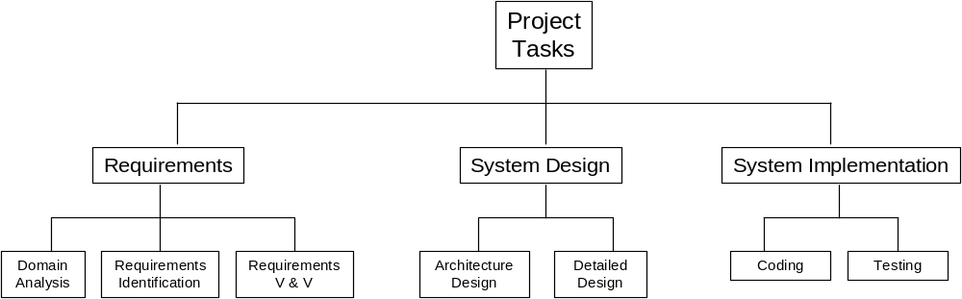

Sample Project Status Template

Project Status Report Card
Submitted by: ____________ |  |  |  | Date submitted (yy-mm-dd): ____________
Reporting period From (yy-mm-dd):______________ To (yy-mm-dd):____________
Progress on planned tasks during this reporting period
Task ID | Task Name | Scheduled start date  (yy-mm-dd) | Scheduled end date  (yy-mm-dd) |  | % complete | Status  (Green, Yellow, Red) | Comment
Details of variance:
Details of proposed corrective actions (if appropriate)
Project Manager Signoff: ___________________ Date (yy-mm-dd):___________________

Project Plan – Sample Table of Contents

1 Introduction
1.1 Project Overview
A high-level overview of the project to include project objectives; list of the members of the Team; and relationship (if any) to prior/existing projects.
1.2 Project Deliverables
A list of the items (e.g. documentation, code) to be delivered.

2 Project Organisation
2.1 Process Model
A description of the process to be employed for the Project.
2.2 Project Responsibilities
An identification of the roles and specific responsibilities to be adopted by each member of the Project Team.
2.3 Change Control Procedures
A description of how change will be handled.
2.4 Configuration Management
A description of how configuration management will be implemented.

3 Project Management Process
3.1 Monitoring and Control Mechanisms
A description of the methods to be used for monitoring progress and controlling the procedures that will be employed.
3.2 Risk Management
A description of main risks and risk mitigation strategy.

4 Work Packages, Schedule, and Budget
4.1 Work Packages
Description of the WBS and deliverables.
4.2 Resource
The allocation of resources to the tasks.
4.3 Schedule
Showing planned starting and finishing dates of each task listed and milestone.
4.4 Budget
Project financial plan

6. Example

Disclaimer: This section provides, for this topic, a graphical representation of a lifecycle. The example is provided to help the reader implement his own lifecycle fitting his project’s context and constraints.

Example of Project Management Practices Lifecycle
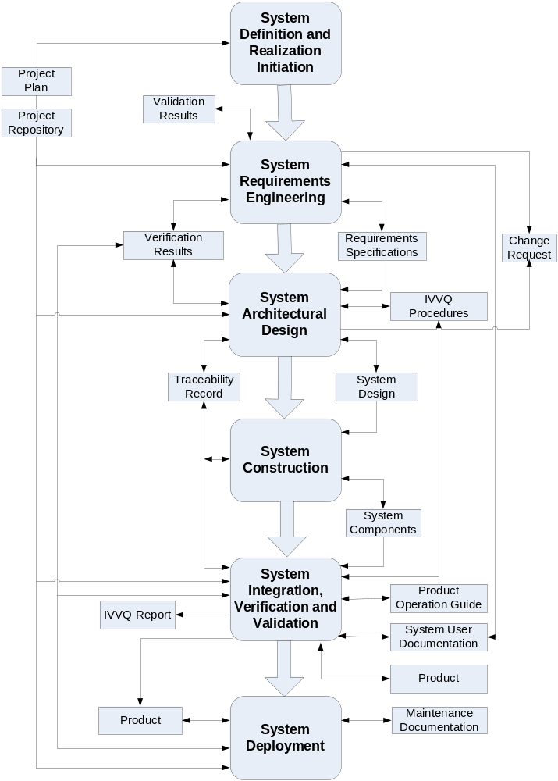
Figure 4 Example of Project Management Practices

7. Checklist

Project Plan Review Checklist
Adapted from: Gilb, T., Graham, D., System Inspection, Addison-Wesley, 1993.

PP 1 (Objectives) | Plan states the objectives of the project, with reference to business needs
PP 2 (WBS) | Plan contains the Work Breakdown Structure (WBS) for all tasks.
PP 3 (Dependencies) | Plan includes the dependencies between WBS tasks and highlight the critical path
PP 4 (Resources) | All resources are specified.
PP 5 (Training) | All training needs are identified.
PP 6 (Schedule) | Plan includes the schedule for all tasks, and who will perform them.
PP 7 (Contingency) | Plan includes a contingency of at least 15%.
PP 8 (Deliverables) | Plan specifies all the deliverables and the required format.
PP 9 (Approval) | Plan is approved by the relevant manager with responsibility for the project.

8. Tool

There are a great many System Project Management tools available both Free/Open Source and Proprietary, standalone and on-line (web based), with a wide variety of functionality. A good informal comparison of such tools is available as a link from the Wikipedia ‘Project management system’ site:
http://en.wikipedia.org/wiki/Comparison_of_project_management_system

The two primary uses of System Project Management system are Scheduling and Providing project status information. The typical features that are useful include:
- Scheduling - One of the most common tasks is to schedule a series of events (tasks, deliverables, milestones), and the complexity of this task can vary considerably depending on how the tool is used. Some common challenges include:
  - Events which depend on one another in different ways or dependencies
  - Scheduling people to work on, and resources required by, the various tasks commonly termed resource scheduling
  - Dealing with uncertainties in the estimates of the duration of each task
  - Arranging tasks to meet various deadlines
  - Juggling multiple projects simultaneously to meet a variety of requirements
- Providing project status information - Project planning system needs to provide a lot of information to various people, to justify the time spent using it. Typical requirements might include:
  - Tasks lists for people, and allocation schedules for resources
  - Overview information on how long tasks will take to complete
  - Early warning of any risks to the project
  - Information on workload, for planning holidays
  - Historical information on how projects have progressed, and in particular, how actual and planned performance are related
  - Optimum utilization of available resource

9. Reference to Other Standards and Models
This section provides references of this deployment package to selected ISO and ISO/IEC Standards and to the Capability Maturity Model IntegrationSM version 1.2 of the System Engineering Institute (CMMI®).
Notes:
- This section is provided for information purpose only.
- Only tasks covered by this Deployment Package are listed in each table.
- The tables use the following convention:
- Full Coverage = F
- Partial Coverage = P
- No Coverage = N

ISO 9001 Reference Matrix
Title of the Task and Step | Coverage  F/P/N | Clause of ISO 9001 | Comments
<details> | <details> | <details>

ISO/IEC 12207 Reference Matrix
Title of the Task and Step | Coverage  F/P/N | Clause of ISO/IEC 12207 | Comments
<details> | <details> | <details>

CMMI Reference Matrix
Title of the Task and Step | Coverage  F/P/N | Objective/ Practice of CMMI V1.2 | Comments
<details> | <details> | <details>

10. References

Key | Reference
[ISO/IEC 12207] | ISO/IEC 12207:2008 Systems and system engineering - System life cycle processes.
[ISO/IEC 24765] | ISO/IEC 24765, Systems and System Engineering Vocabulary.
[ISO/IEC 29110] | System Engineering — Lifecycle Profiles for Very Small Entities (VSEs) — Part 5-1: Management and Engineering Guide - Basic VSE Profile
[Dalcher07] | Successful IT Projects, D. Dalcher & L. Brodie, Thomson, 2007
[Jalote02] | System Project Management in Practice, P. Jalote, Addison-Wesley, 2002
[Jones04] | System Project Management Practices: Failure Versus Success, C. Jones, Crosstalk, October 2004.
[PMBOK04] | Guide to the Project Management Body of Knowledge, Project Management Institute, 2004 accessible from www.pmi.org
[Putnam97] | Industrial Strength System: Effective Management Using Measurement, L. H. Putnam and W. Myers, IEEE, 1997.
[Sommerville06] | System Engineering (8 ed), I. Sommerville, Addison-Wesley, 2006

11. Evaluation Form

Deployment Package: Project Management V1.3
Your feedback will allow us to improve this deployment package; your comments and suggestions are welcomed.
1. How satisfied are you with the CONTENT of this deployment package?
❑ Very Satisfied  Satisfied  Neither Satisfied nor Dissatisfied  Dissatisfied  Very Dissatisfied
2. The sequence in which the topics are discussed, are logical and easy to follow?
❑ Very Satisfied  Satisfied  Neither Satisfied nor Dissatisfied  Dissatisfied  Very Dissatisfied
3. How satisfied were you with the APPEARANCE/FORMAT of this deployment package?
❑ Very Satisfied  Satisfied  Neither Satisfied nor Dissatisfied  Dissatisfied  Very Dissatisfied
4. Have any unnecessary topics been included? (please describe)
5. What missing topic would you like to see in this package? (please describe)
- Proposed topic:
- Rationale for new topic
6. Any error in this deployment package?
  - Please indicate:
      - Description of error :
      - Location of error (section #, figure #, table #) :
7. Other feedback or comments:
8. Would you recommend this Deployment package to a colleague from another VSE?

❑ Definitely  Probably  Not Sure  Probably Not  Definitely Not
Optional
- Name:
- e-mail address : __________________________________

Email this form to: claude.y.laporte@etsmtl.ca or joseph.marvin@incose.org

INCOSE Web Site http://www.incose.org/practice/whatissystemseng.aspx
HONOUR Eric, “Systems engineering return on investment”, Defence and Systems Institude, School of electrical and Information Engineering, University of South Australia, January 2013
Roles are defined in a next section. Roles are also defined in ISO/IEC 29110 Part 5-1
SM CMM Integration is a service mark of Carnegie Mellon University. ® Capability Maturity Model, CMMI are registered in the U.S. Patent and Trademark Office by Carnegie Mellon University.

