Deployment Package
Project Management
Entry Profile

Notes:
This document is the intellectual propriety of its author’s organization. However, information contained in this document is free of use. The distribution of all or parts of this document is authorized for non commercial use as long as the following legal notice is mentioned:

© École de Technologie Supérieure

Commercial use of this document is strictly forbidden. This document is distributed in order to enhance exchange of technical and scientific information.
This material is furnished on an “as-is” basis. The author(s) make(s) no warranties of any kind, either expressed or implied, as to any matter including, but not limited to, warranty of fitness for purpose or merchantability, exclusivity, or results obtained from use of the material.
The processes described in this Deployment Package are not intended to preclude or discourage the use of additional processes that Very Small Entities may find useful.

Authors | G. Hernandez - École de Technologie Supérieure (ETS), (Canada)  W. Gonzalez - École de Technologie Supérieure (ETS), (Canada)
Editor | C. Y. Laporte – École de Technologie Supérieure (ETS), (Canada)
Creation date | 25/06/2010
Last update | September 21, 2012
Status | Draft
Version | 0.3

Version History

Date  (dd-mm-yyyy) | Version | Author(s) | Modification
19/07/2010 | 0.1 | G. Hernandez  W. Gonzalez | Document Creation
19/11/2010 | 0.2 | G. Hernandez  W. Gonzalez | Document Update
July 9th 2012 | 0.3 | C. Laporte | Updates

Abbreviations/Acronyms

Abre./Acro. | Definitions
DP | Deployment Package - a set of artefacts developed to facilitate the implementation of a set of practices, of the selected framework, in a Very Small Entity.
PM | Project Management
VSE | Very Small Entity – an enterprise, organization, department or project having up to 25 people.
VSEs | Very Small Entities
PM | Project Management
SOW | Statement of Work

Table of Contents

1. Technical Description 4
Purpose of this document 4
Why is the Project Management Process Important? 4
2. Definitions 6
Generic Terms 6
Specific Terms 6
3. Relationships with ISO/IEC 29110 7
4. Description of Processes, Activities, Tasks, Steps, Roles & Products 8
4.1 PM Activities 8
4.1.1. Activity PM.1 Project Planning 9
4.1.2. Activity PM.2 Project Plan execution 12
4.1.3. Activity PM.3 Project assessment and control 13
4.1.4. Activity PM.4 Project closure 14
4.2. Role Description 16
4.3 Product Description 17
4.4. Artefact Description 21
5. Template & Tools 23
Template 23
Tools 28
6. Example of Activities lifecycle 30
7. Checklist 31
8. References 32
9. Evaluation Form 33

1. Technical Description

Purpose of this document
This Deployment Package (DP) supports the Entry Profile as defined in ISO/IEC TR 29110-5-1-1:2012, the Management and engineering guide [ISO/IEC 29110]. The Entry Profile is one profile of the Generic profile group. The Generic profile group is applicable to VSEs that do not develop critical software. The Generic profile group is composed of 4 profiles: Entry, Basic, Intermediate and Advanced. The Generic profile group does not imply any specific application domain. The Entry profile is targeted to VSEs working on small projects (e.g. at most six person-months effort) and for start-up VSEs.

The Entry Profile provides a foundation for a migration to the Basic Profile Processes. The Entry Profile is composed of two processes: the Project Management Process and the Software Implementation Process. This DP supports the Project Management process. Another DP supports the Software Implementation process.

A DP is a set of artefacts developed to facilitate the implementation of a set of practices in a Very Small Entity (VSE). A DP is not a process reference model (i.e. it is not prescriptive). The elements of a typical DP are: description of processes, activities, tasks, roles and products, template, checklist, example and tools.

The content of this document is not normative, it is entirely informative.

This document is intended to be used by a VSE to establish processes to implement any development approach or methodology including, e.g., agile, evolutionary, incremental, test driven development, etc. based on the organization or project needs of a VSE.

ISO/IEC TR 29110-5-1-1 is available at no cost on the following ISO site: http://standards.iso.org/ittf/PubliclyAvailableStandards/index.html

Why is the Project Management Process Important?
Many software products fail not because there is no market, but because the cost of creating the software far outstrips any profit. Currently approximately half a million project managers worldwide are responsible for in the region of one million software projects each year, which produce software worth USD$600 billion. It is now accepted that many of these projects fail to fulfil customers' expectations or fail to deliver the software within budget and on schedule. [Putnam97] suggests that about one-third of projects have cost and schedule overruns of more than 125%.

Project Management Failure
Software project failure is often devastating to an organization. Schedule slips, buggy releases and missing features can mean the end of the project or even financial ruin for a company. Some of the major reasons for projects running out of control are: unclear objectives; bad planning; new technology; a lack of a project management methodology; and insufficient staff [Jalote02]. At least three of these five reasons clearly relate to project management.
While there are many reasons why software projects fail, one of the most important is incorrect management of the project. Good project management cannot guarantee project success, however bad project management usually results in project failure. The software is delivered late, costs more and fails to meet its requirements. [Sommerville06]. Clearly, by using effective project management techniques a project manager can improve the chances of success.
A study by Capers Jones [Jones04] of approximately 250 software projects between 1995 and 2004 shows an interesting pattern. When comparing projects that successfully achieved their cost and schedule estimates against those that ran late, were over budget, or were cancelled without completion, six common problems were observed: poor project planning, poor cost estimating, poor measurements, poor milestone tracking, poor change control, and poor quality control. By contrast, successful software projects tended to be better than average in all six of these areas. Perhaps the most interesting aspect of these six problem areas is that all are associated with project management rather than with technical personnel.

Project Management Success
There are many ways to make large software systems fail. There are only a few ways of making them succeed. It is commonly agreed that project management is the key factor that tends to push projects along either the path to success or the path to failure. Among the most important project management practices leading to success are those of planning and estimating before the project starts, absorbing changing requirements during the project, and successfully minimizing bugs or defects.
Successful projects always excel in these critical activities: planning, estimating, change control, and quality control. By contrast, projects that run late or fail typically had flawed or optimistic plans, had estimates that did not anticipate changes or handle change well, and failed to control quality [Jones04].

2. Definitions

In this section, the reader will find two sets of definitions. The first set defines the terms used in all Deployment Packages, i.e. generic terms. The second set of terms used in this Deployment package, i.e. specific terms.

Generic Terms
Process: set of interrelated or interacting activities which transform inputs into outputs [ISO/IEC 12207].

Activity: a set of cohesive tasks of a process [ISO/IEC 12207].

Task: required, recommended, or permissible action, intended to contribute to the achievement of one or more outcomes of a process [ISO/IEC 12207].

Sub-Task: When a task is complex, it is divided into sub-tasks.

Step: In a deployment package, a task is decomposed in a sequence of steps.

Role: a defined function to be performed by a project team member, such as testing, filing, inspecting, coding. [ISO/IEC 24765]

Product: piece of information or deliverable that can be produced (not mandatory) by one or several tasks. (e. g. design document, source code).

Artefact: information, which is not listed in ISO/IEC 29110 Part 5, but can help a VSE during the execution of a project.

Specific Terms
Customer: Organization or person that receives a product or service.
[ISO 12207:2008]

Project: Endeavour with defined start and finish dates undertaken to create a product or service in accordance with specified resources and requirements.
[ISO 12207:2008]

Resource: Asset that is utilized or consumed during the execution of a process.
[ISO 12207:2008]

Work Breakdown Structure (WBS): a deliverable-oriented hierarchical decomposition of the work to be executed by the project team to accomplish the project objectives and create the required deliverables. It organizes and defines the total scope of the project. [PMI 2008]

3. Relationships with ISO/IEC 29110

This deployment package covers the activities related to Project Management of ISO/IEC TR 29110-5-1-1 for Very Small Entities (VSEs) – Generic Profile Group: Entry Profile [ISO/IEC 29110].
The Guide provides Project Management and Software Implementation processes which integrate practices based on the selection of ISO/IEC 12207- Systems and Software Engineering —Software Life Cycle Processes:2008 and ISO/IEC 15289 Systems and Software Engineering – Software Life Cycle Process – guidelines for the content of software life cycle process information products (documentation):2006 standards elements.
The purpose of the Project Management process is to establish and carry out in a systematic way the tasks of the software implementation project, which allows complying with the project’s objectives in the expected quality, time and cost.
The purpose of the Software Implementation process is the systematic performance of the analysis, software component identification, construction, integration and tests, and product delivery activities for new or modified software products according to the specified requirements.

Both processes are interrelated (see Figure 1).

Figure 1 — Entry profile processes (ISO/IEC 29110)

4. Description of Processes, Activities, Tasks, Steps, Roles & Products

The following diagram shows the flow of information between the Project Management Process activities including the most relevant work products and their relationship.

Figure 2 Project Management process diagram (ISO/IEC 29110)

4.1 PM Activities

The purpose of the Project Management process is to establish and carry out in a systematic way the tasks of the software implementation project, which allows complying with the project’s objectives in the expected quality, time and costs.
The Project Management Process has the following activities:
- PM.1 Project Planning
- PM.2 Project Plan Execution
- PM.3 Project Assessment and Control
- PM.4 Project Closure

4.1.1. Activity PM.1 Project Planning

The Project Planning activity documents the planning details needed to manage the project. The activity provides:
- Reviewed Statement of Work and the tasks needed to provide the contract deliverables and to satisfy customer requirements.
- Project quality assurance approach through verification and validation of work products/deliverables, customer reviews.
- Work team and customer roles and responsibilities.
- Project resources needs.
- Estimates of effort, cost and schedule.
- Identified project risks.
- Project repository to store, handle and deliver controlled product and document versions and baselines.

Role | Task List | Input Products | Output Products
PM  WT | PM.1.1 Review the Statement of Work | Statement of Work | Statement of Work [reviewed]
PM  WT | PM.1.2 Identify the specific tasks to be performed in order to produce the deliverables and their software components identified in the Statement of Work. Include tasks in the SI process along with verification, validation and reviews with Customer and Work Team tasks to assure the quality of work products. | Statement of Work[reviewed] | Project Plan  - Tasks
PM  WT | PM.1.3 Establish the Estimated Duration to perform each task. | Project Plan  - Tasks | Project Plan  - Estimated Duration
PM  WT | PM.1.4 Identify and document the resources: human, material, equipment and tools. | Statement of Work | Project Plan  - Resources
PM  WT | PM.1.5 Establish the Composition of Work Team assigning roles and responsibilities according to the Resources. | Project Plan  - Resources | Project Plan  - Composition of Work Team
PM  WT | PM.1.6 Assign estimated start and completion dates to each one of the tasks in order to create the Schedule of the Project Tasks. | Project Plan  - Tasks  - Estimated Duration  - Composition of Work Team | Project Plan  - Schedule of the Project Tasks
PM | PM.1.7 Calculate and document the project Estimated Effort and Cost. | Project Plan  - Schedule of the Project Tasks  - Resources | Project Plan  - Estimated Effort and Cost
PM  WT | PM.1.8 Identify and document the risks which may affect the project. | All elements previously defined | Project Plan  - Identification of Project Risks
PM | PM.1.9 Generate the Project Plan integrating the elements previously identified and documented. | All elements previously defined | Project Plan  - Tasks  - Estimated Duration  - Resources  - Composition of Work Team  - Schedule of the Project Task  - Estimated Effort and Cost  - Identification of Project Risks
PM  CUS | PM.1.10 Review and accept appropriate parts of the Project Plan.  Customer reviews and accepts the Project Plan. | Project Plan | Project Plan [accepted]
PM  WT | PM.1.11 Establish the project repository. | Project Plan | Project Repository

Project Planning Process
Objectives: | The primary objective of the Project Planning Process is to produce and communicate an effective and workable project plan.  This process determines the scope of the project management and technical activities, identifies process outputs, project tasks and deliverables, establishes schedules for project task conduct and required resources to accomplish project tasks.
Rationale: | Whatever the size of the project, good planning is essential if it is to succeed. Effective software project management depends on thoroughly planning the progress of a project. A plan formulated at the start of a project should act as a driver for the project. The initial plan should be the best possible plan given the available information. It should evolve as the project progresses and better information becomes available.
Roles: | Project Manager
 | Work Team
Artifacts: | Project Plan
 | Project Description
Steps: | Step 1. Identify products and activities
 | Step 2. Create a WBS (work breakdown structure)
 | Step 3. Estimate resources, effort and duration
 | Step 4. Create a schedule
Step Description: | Step 1. Identify products and activities  The project manager identifies all the products, tasks and activities that need to be completed before the project can be finished. It may be necessary for the project manager to liaise with the customer and the work team to fully understand the objectives of the project and to break down each one into its constituent parts.  Step 2. Create a WBS (Work Breakdown Structure)  The WBS aims to identify all of the projects tasks that need to be completed and organises them in a hierarchal format, where smaller sub-tasks contribute to the completion of a larger task at a higher level.  A typical WBS would consist of:  - Project  - Task  - Sub-Task  - Work Package  - Effort  Once a WBS is complete, project milestones (key deliverables) can be identified and may be used for project tracking.  Tip: Many software packages such as MS Project can structure WBS information and automatically generate useful graphical representations.  Step 3. Estimate resources, effort and duration  For each task in the WBS the effort and duration should be estimated and the overall resources required to complete the project calculated.  Typically a ‘bottom-up’ approach is used to estimate the effort required for each task in the WBS in terms of person hours or person days.  In order to create a schedule of tasks and estimate total project budget, it is necessary to estimate the resources (people, equipment, services, etc.) required to complete each task.  Step 4. Create a schedule  Tasks should be organised into a coherent sequence, including parallel activities, and mapped against time and resources, to produce a schedule of tasks to be completed by individuals during the lifetime of the project.

4.1.2. Activity PM.2 Project Plan execution
The Project Plan Execution activity implements the documented plan on the project. The activity provides:
- Monitoring the project against the Project plan.
- Status of the Project Plan Execution
- Change Request initiated by Customer
- Reviews and agreements with the Customer.

Role | Task List | Input Products | Output Products
PM  WT | PM.2.1 Monitor and record status of the Project Plan execution. | Project Plan | Progress Status Record
PM  CUS  WT | PM.2.2 Conduct meetings with the Customer, record agreements and track them to closure.  Change Request initiated by Customer, needs to be negotiated to reach acceptance of both parties. | Project Plan  Progress Status Record  Change Request | Meeting Record  Change Request [accepted]

Project Plan Execution
Objectives: | To implement the actual work tasks of the project in accordance with the project plan.
Rationale: | Ideally when the project plan has been agreed and communicated to all team members, work of the development of the product which is the subject of the project should commence.
Roles: | Project Manager
 | Work Team
 | Customer
Artifacts: | Project Status Record
 | Change Requests
Steps: | Step 1. Obtain agreement on project plan
 | Step 2. Take corrective action
Step Description: | Step 1. Obtain an agreement on project plan  Agreement must be reached between the project manager and all members of the project team on the defined project parameters and targets as set out in the project plan. It may also be necessary to gain the agreement of the customer in terms of project duration and deliverables schedule.  Step 2. Take corrective action  When deviations between the project plan and actual project progress have been indentified or the implementation of change requests agreed, corrective action will need to be taken to ensure than project continues according to revised plan.

4.1.3. Activity PM.3 Project assessment and control
The Project Assessment and Control activity evaluates the performance of the plan. The activity provides:
- Evaluation of actual plan performance and progress against targets.
- Track change requests.
Role | Task List | Input Products | Output Products
PM  WT | PM.3.1 Evaluate project progress with respect to the Project Plan, comparing:  - actual tasks against planned tasks  - actual resource allocation against planned resources  - actual cost against budget estimates  - actual time against planned schedule  - actual risk against previously identified | Project Plan  Progress Status Record | Progress Status Record [evaluated]
PM  WT | PM.3.2 Evaluate and Track the changes request from customer. | Change Request | Change Request [Tracked]
PM  WT | PM. 3.3 Establish actions to correct deviations or problems and track them to closure. | Progress Status Record

Project Assessment and Control Process
Objectives: | The purpose of the Project Assessment and Control is to determine the status of the project and ensure that the project performs according to plans and schedules, within projected budgets and it satisfies technical objectives.  This process includes redirecting the project activities, as appropriate, to correct identified deviations and variations from other project management or technical processes. Redirection may include re-planning as appropriate.
Rationale: | A project plan is a document that can be used to guide the execution of a project. Unless the actual performance of the execution of the project is tracked against the plan, the plan will have limited value beyond the initiation of the project.
Roles: | Project Manager
 | Work Team
Artifacts: | Project Plan
 | Change Requests
Steps: | Step 1. Review plan
 | Step 2. Identify plan deviations
 | Step 3. Process change requests
Step Description: | Step 1. Review plan  Periodically the project plan should be reviewed by the project manager against the actual progress. Deviation from planned progress may require Corrective Action to be performed, resulting in an updated project plan.  Step 2. Identify plan deviations  Based on any deviations discovered during the Review Plan activity, it may be necessary to identify and evaluate significant cost, schedule and technical performance deviations and undertake Corrective Actions.  Step 3. Process change requests  Requirements change requests (any change that comes in after project has started) must be managed and controlled, as there will be an impact on the project plan, schedule and cost. Typically for a change request the following steps should be undertaken:  - Estimate effort to implement change  - Re-estimate project schedule and cost  - Obtain customer sign-off on agree change

4.1.4. Activity PM.4 Project closure
The Project Closure activity provides the project’s documentation and products in accordance with contract requirements. The activity provides:
- Support of Customer product acceptance
- Completion of the project and sign of the Acceptance Record
- Summary and updated project repository for project closure
Role | Task List | Input | Output
PM  CUS | PM.4.1. Formalize the completion of the project, providing acceptance support and getting the Acceptance Record signed. | Project Plan  Software Configuration [ready to be delivered] | Acceptance Record  Software Configuration [accepted]
PM | PM.4.2 Update Project Repository. | PM products  - Project Plan  - Change Request  - Progress Status - Record  - Meeting Record  - Acceptance Record  SI products  - Software Component Identification  - Test Cases and Test Procedures  - Software Components  - Test Report  - Software Configuration | Project Repository [updated]

Project Closure
Task Name
Objectives: | Project Closure typically involves releasing the final deliverables to the customer, handing over project documentation to the business, terminating supplier contracts, releasing project resources and communicating project closure to all stakeholders.
Rationale: | A project closure process ensures that all project outputs are delivered.
Roles: | Project Manager
 | Customer
Artifacts: | Project plan
 | Software
 | Acceptance document
Steps: | Step 1. Deliver software
 | Step 2. Obtain customer acceptance
 | Step 3. Baseline product documentation
Step Description: | Step 1. Deliver software  The software system and associated documentation is delivered to the customer as described in the delivery instructions.  Step 2. Customer acceptance  The signing of an Acceptance Document by the customer indicates the formal the closure of the project and that the software has been delivered as specified in the contract delivery instructions.  Step 3. Baseline product documentation  As there may be multiple versions of the product over time and/or continued product maintenance, it is necessary to formally record all major project documentation (such as requirements, project plans, software product, acceptance, etc.) at closure stage.

4.2. Role Description

This is an alphabetical list of the roles, its abbreviations and suggested competencies description. This list is showed as a four-column table for presentation purpose only.

 | Role | Abbreviation | Competency
1. | Customer | CUS | Knowledge of the Customer processes and ability to explain the Customer requirements.  The Customer (representative) must have the authority to approve the requirements and their changes.  The Customer includes user representatives in order to ensure that the operational environment is addressed.  Knowledge and experience in the application domain.
2. | Project Manager | PM | Leadership capability with experience making decisions, planning, personnel management, delegation and supervision, finances and software development.
3. | Work Team | WT | Knowledge and experience according to their roles on the project.

4.3 Product Description

This is an alphabetical list of the input, output and internal process products, its descriptions, possible states and the source of the product. The source can be another process or an external entity to the project, such as the Customer. This list is showed as a four-column table for presentation purpose only. Product items in the following tables are based on ISO/IEC 15289 Information Items with some exceptions.

The product status gives the information to the project team about the type of work (tasks) already done on the product (for example: evaluated, verified, tested, baselined). This information can be used to start next tasks which can use the product as an input. Some products have no status assigned because they are only informative and they do not change the content (for example: Acceptance Record, Correction Register, Project Repository Backup, Verification/Validation Results).

 | Name | Description | Source
1. | Acceptance Record | Documents the customer acceptance of the deliverables of the project. It may have the following characteristics:  - Record of the receipt of the delivery  - Identifies the date received  - Identifies the delivered elements  - Record of customer verification of the deliverables according to the Customer agreement.  - Identifies any open issues (if applicable)  - Signed by receiving Customer | Project Management
2. | Change Request | Identifies a software, or documentation problem or desired improvement, and requests modifications.  It may have the following characteristics:  - Identifies purpose of change  - Identifies request status (new, accepted, rejected)  - Identifies requester contact information  - Impacted system(s)  - Impact to operations of existing system(s) defined  - Impact to associated documentation defined  - Criticality of the request, date needed by  The applicable statuses are: initiated, evaluated, accepted and rejected. | Software Implementation  Customer  Project Management
3. | Meeting Record | Records the agreements established with Customer and/or Work Team. It may have the following characteristics:  - Purpose of meeting  - Attendees  - Date, place held  - What was accomplished  - Identifies issues raised  - Any open issues  - Agreements  - Next meeting, if any.  The applicable status is: updated. | Project Management
4. | Progress Status Record | Records the status of the project against the Project Plan.  It may have the following characteristics:  - Status of actual tasks against planned tasks  - Status of actual results against established objectives / goals  - Status of actual resource allocation against planned resources  - Status of actual cost against budget estimates  - Status of actual time against planned schedule  - Status of actual risk against previously identified  - Record of any deviations from planned tasks and reason why.  The applicable status is: evaluated. | Project Management
5 | Project Plan | Presents how the project processes and activities will be executed to assure the project’s successful completion, and the quality of the deliverable products. It Includes the following elements which may have the characteristics as follows:  - Product Description  - Purpose  - General Customer requirements  - Scope description of what is included and what is not  - Deliverables - list of products to be delivered to Customer  - Tasks, including reviews with Customer and Work Team, to assure the quality of work products. Tasks may be represented as a Work Breakdown Structure (WBS).  - Relationship and Dependence of the Tasks  - Estimated Duration of tasks  - Resources (humans, materials, standards, equipment and tools), and the schedule when the resources are needed.  - Composition of Work Team Role and Responsibility are identified  - Schedule of the Project Tasks, the expected start and completion date, for each task.  - Estimated Effort and Cost  - Identification of Project Risks  - Software Configuration Identification  - Product repository  - List of items with version information  The applicable statuses are: verified, accepted, updated and reviewed. | Project Management
6 | Project Repository | Electronic container to store project work products and deliveries. It may have the following characteristics:  - Stores project work products  - Stores released deliverables products  - Storage and retrieval capabilities  - Stores project measures Ability to browse content  - Listing of contents with description of attributes  - Sharing and transfer of work products between work team.  - Effective controls over access  - Maintain work products descriptions  - Recovery of archive versions of work products  - Ability to report work products status  - Changes to work products are tracked to Change Requests  The applicable statuses are: recovered and updated. | Project Management
7. | Requirements Specification | Identifies the software requirements.  It may have the following characteristics:  - Introduction –general description of software and its use within the scope of the customer business;  - Requirements description:  - Functionality – established needs to be satisfied by the software when it is used in specific conditions. Functionality must be adequate, accurate and safe.  - User interface – definition of those user interface characteristics that allow to understand and learn the software easily so the user be able to perform his/her tasks efficiently including the interface exemplar description;  - External interfaces – definition of interfaces with other software or hardware;  Each requirement is identified, unique and it is verifiable or can be assessed.  The applicable statuses are: verified, and validated. | Software Implementation
8. | Software | Software item (software source and executable code) for a Customer, constituted by a collection of integrated Software Components.  The applicable statuses are: tested | Software Implementation
9. | Software Component | A uniquely identified and consistent set of software products including:  - Requirements Specification  - Software  The applicable statuses are: delivered and accepted. | Software Implementation
10 | Software Component Identification | Textual and graphical information on the software structure. This structure may include the following parts:  Describes the overall Software structure:  - Identifies the required Software Components  - Identifies the relationship between Software Components | Software Implementation
11 | Software Configuration | A uniquely identified and consistent set of software products including:  - Requirements Specification  - Software Components  - Software  - Test Report  - Product Operation Guide  - Software User Documentation  The applicable statuses are: delivered and accepted. | Software Implementation
12 | Statement of Work | Description of work to be done related to software development. It may Include:  - Product Description  - Purpose  - General Customer requirements  - Scope description of what is included and what is not  - Deliverables list of products to be delivered to Customer  The applicable status is: reviewed. | Customer
13. | Test Cases and Test Procedures | Elements needed to test code. Test Case may include:  - Identifies the test case  - Test items  - Input specifications  - Output specifications  - Environmental needs  - Special procedural requirements  - Interface dependencies  Test Procedures may include:  - Identifies: test name, test description and test completion date  - Identifies potential implementation issues  - Identifies the person who completed the test procedure  - Identifies prerequisites  - Identifies procedure steps including the step number, the required action by the tester and the expected results | Software Implementation
14. | Test Report | Documents the tests execution. It may include:  - A summary of each defect  - Identifies the tester who found each defect  - Identifies the affected function(s) for each defect  - Identifies the date when each defect originated  - Identifies the date when each defect was resolved  - Identifies the person who resolved each defect | Software Implementation

4.4. Artefact Description

This is an alphabetical list of the artefacts that could be produced to facilitate the documentation of a project. The artefacts are not required by Part 5, they are optional.

Artifacts | Definition
Project Description | A high level description of the project to include; Scope; Objectives and major Deliverables.
Software | A consistent set of software products which include:  - Requirements Specification  - Software Components  - Software (unit, product, item)  - Test Reports  - Operational Manual  - User Manual

5. Template & Tools

Template

The following templates are provided with this deployment package. Choose and customize them to your project.

Acceptance Record Template
- Project Identification
<Provide the company name and the project name. Include the names of the responsible(s), its (their) e-mail and telephone numbers.>

- Project Scope
<Provide a short description of the software being specified and its purpose, including relevant benefits, objectives, and goals. Relate the software to corporate goals or business strategies.>

- Product Perspective
<Describe the context and origin of the product being specified in this document. For example, state whether this product is a follow-on member of a product family, a replacement for certain existing systems, or a new, self-contained product. A simple diagram that shows the major components of the overall system can be helpful.>

- Product Features
<Summarize the major features the product contains or the significant functions that it performs or lets the user perform. These might include: performance requirements, security or safety exigencies, etc. For each one, indicate its importance rate (high, medium, low). Organize the functions to make them understandable to any reader of this document. >

- Operating Environment (Optional)
<Describe the environment in which the software will operate, including the hardware platform, operating system and versions, and any other software components or applications with which it must peacefully coexist.>

- Constraints (Optional)
<Describe any items or issues that will limit the options available to the developers. These might include: corporate or regulatory policies; hardware limitations (timing requirements, memory requirements), etc.>

- Other Requirements (Optional)
<Define any other requirements not covered elsewhere in the document. This might include internationalization requirements, legal requirements, reuse objectives for the project, and so on. Add any new sections that `are pertinent to the project.>

Work Breakdown Structure (WBS)

This can be used in an Excel spreadsheet, for example as;
Task Number | Type of Task | Description of Task | Associated Deliverables | Estimation (person days)

Partial example of WBS

Task Number | Type of Task | Description of Task | Estimation (person days)
1 | Main task | Software Implementation Initiation | 3 (2+1)
1.1 | Sub-task | Review of Project Plan | 2
1.2 | Sub-task | Set implementation environment | 1
2 | Main task | Software Requirements Analysis | 12 (5+2+3+2)
2.1 | Sub-task | Collect Information | 5
2.2 | Sub-task | Identify project’s scope | 2
2.3 | Sub-task | Identify and capture requirements | 3
2.4 | Sub-task | Structure and prioritize requirements | 2
3 | Main task | Software Components Identification | 21 (10+6+5)
3.1 | Sub-task | Understand Requirements Specification | 10
3.2 | Sub-task | Document Components Identification | 6
3.3 | Sub-task | Incorporate Components | 5
4 | Main task | Software Construction | 45 (15+25+5)
4.1 | Sub-task | Design | 15
4.2 | Sub-task | Code | 25
4.3 | Sub-task | Verify | 5
5. | ... | ... | ...

Partial example of graphical WBS

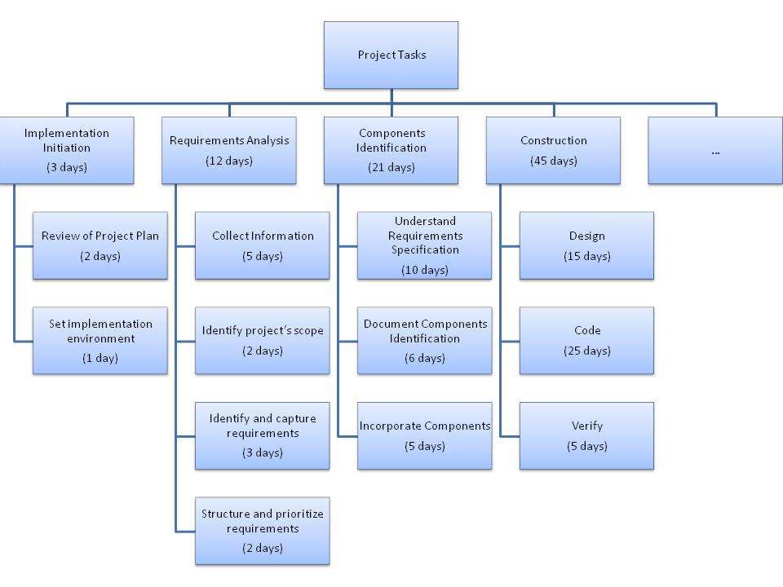

Project Plan – Table of contents

1 Project Overview
  - Purpose, scope and objectives
- Define the purpose and scope of the project.
- List of the members of the Team.
  - Project Deliverables
- A list of the items (e.g. documentation, code) to be delivered.
- Specify the delivery media.

2 Project Organisation
2.1 Process Model
A description of the process to be employed for the Project.
2.2 Project Responsibilities
An identification of the roles and specific responsibilities to be adopted by each member of the Project Team.
2.3 Change Control Procedures
A description of how change will be handled.
2.4 Configuration Management
A description of how configuration management will be implemented.

3 Work Packages, Schedule, and Budget
3.1 Work Packages
Description of the WBS and deliverables.
3.2 Resource
The allocation of resources to the tasks.
3.3 Schedule
Showing planned starting and finishing dates of each task listed and milestone.
3.4 Budget
Project financial plan

Change Request – Sample of Contents

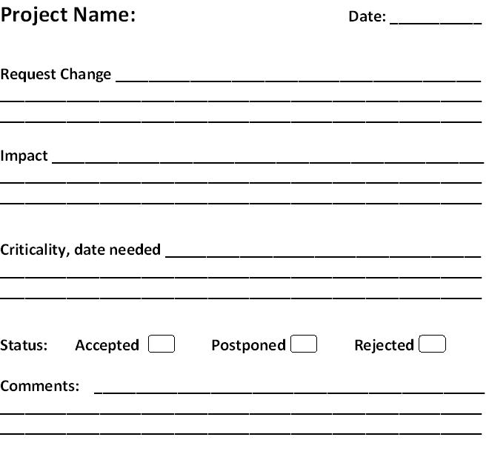

Meeting Report – Sample of Contents

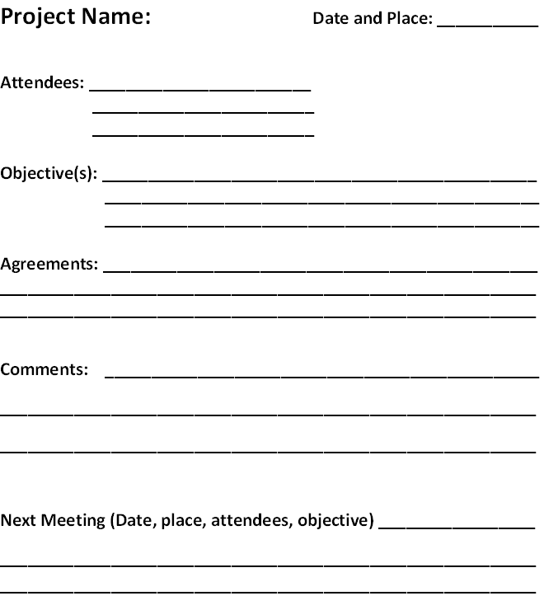

Tools

There are many Software Project Management tools available both Free/Open Source and Proprietary, standalone and on-line (web based), with a wide variety of functionality. A good informal comparison of such tools is available as a link from the Wikipedia ‘Project management software’ site:
http://en.wikipedia.org/wiki/Comparison_of_project_management_software

The two primary uses of Software Project Management software are scheduling and providing project status information. The typical features that are useful include:
- Scheduling - One of the most common tasks is to schedule a series of events (tasks, deliverables, milestones), and the complexity of this task can vary considerably depending on how the tool is used. Some common challenges include:
  - Events which depend on one another in different ways or dependencies
  - Scheduling people to work on, and resources required by, the various tasks commonly termed resource scheduling
  - Dealing with uncertainties in the estimates of the duration of each task
  - Arranging tasks to meet various deadlines
  - Juggling multiple projects simultaneously to meet a variety of requirements
- Providing project status information - Project planning software needs to provide a lot of information to various people, to justify the time spent using it. Typical requirements might include:
  - Tasks lists for people, and allocation schedules for resources
  - Overview information on how long tasks will take to complete
  - Information on workload, for planning holidays
  - Information on how actual and planned performance are related
  - Optimum utilization of available resource

6. Example of Activities lifecycle

Disclaimer: This section provides, for this topic, a graphical representation of a lifecycle. The example is provided to help the reader implement his own lifecycle fitting his IT project’s context and constraints.

Example of Project Management Practices Lifecycle
This is only an example – use SPEM stencil for Microsoft Visio (http://www.pa.icar.cnr.it/cossentino/FIPAmeth/docs/SPEM.vss ) in order to produce such a diagram.
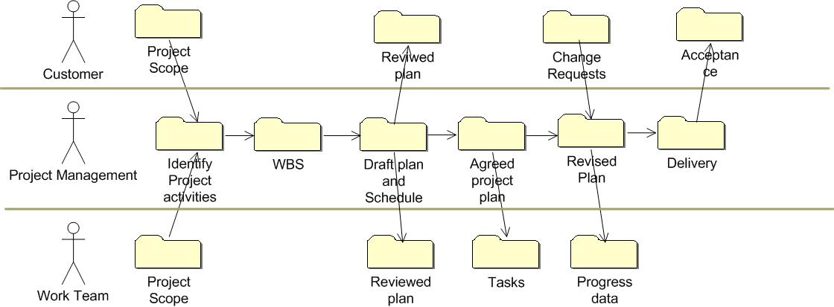

Figure 3. Example of Project Management Practices

7. Checklist

Project Plan Review Checklist

This checklist captures common tasks that should be present in a Project Plan.

Adapted from: Gilb, T., Graham, D., Software Inspection, Addison-Wesley, 1993.

PP 1 (Objectives) | Plan states the objectives of the project, with reference to business needs
PP 2 (WBS) | Plan contains the Work Breakdown Structure (WBS) for all tasks.
PP 3 (Resources) | All resources are specified.
PP 4 (Schedule) | Plan includes the schedule for all tasks, and who will perform them.
PP 5 (Deliverables) | Plan specifies all the deliverables and the required format.
PP 6 (BUDGET) | The financial plan of the project is specified
PP 7 (RESPONSABILITIES) | All roles and responsibilities specific to be adopted by each member of the project’s team are identified.
PP 8 (CONTROL OF CHANGES) | It is described how the changes will be managed
PP 9 (CONFIGURATION MANAGEMENT) | It is described how configuration management will be implemented.
PP 10 (Approval) | Plan is approved by the relevant manager with responsibility for the project.

8. References

Key | Reference
[ISO/IEC 12207] | ISO/IEC 12207:2008 Systems and software engineering - Software life cycle processes.
[ISO/IEC 15289] | ISO/IEC 15289:2006 Systems and software engineering - Content of systems and software life cycle process information products (Documentation)
[ISO/IEC 24765] | ISO/IEC 24765:2011, Systems and Software Engineering Vocabulary.  An electronic version of the glossary is available at: http://pascal.computer.org/sev_display/index.action
[ISO/IEC 29110] | ISO/IEC TR 29110-5-1-1:2012 Software Engineering — Lifecycle Profiles for Very Small Entities (VSEs) — Part 5-1-1: Management and Engineering Guide –Generic Profile Group: Entry Profile  ISO/IEC TR 29110-5-1-1 is available at no cost on the following ISO site: http://standards.iso.org/ittf/PubliclyAvailableStandards/index.html
[Jalote02] | Software Project Management in Practice, P. Jalote, Addison-Wesley, 2002
[Jones04] | Software Project Management Practices: Failure Versus Success, C. Jones, CrossTalk, October 2004.
[PMI 2008] | A Guide to the Project Management Body of Knowledge, Project Management Institute, 2008.
[Putnam97] | Industrial Strength Software: Effective Management Using Measurement, L. H. Putnam and W. Myers, IEEE, 1997.
[Sommerville06] | Software Engineering (8 ed), I. Sommerville, Addison-Wesley, 2006

9. Evaluation Form

Deployment Package - Project Management- Entry Profile V 0.3
Your feedback will allow us to improve this deployment package, your comments and suggestions are welcomed.
1. How satisfied are you with the CONTENT of this deployment package?
❑ Very Satisfied  Satisfied  Neither Satisfied nor Dissatisfied  Dissatisfied  Very Dissatisfied
2. The sequence in which the topics are discussed, are logical and easy to follow?
❑ Very Satisfied  Satisfied  Neither Satisfied nor Dissatisfied  Dissatisfied  Very Dissatisfied
3. How satisfied were you with the APPEARANCE/FORMAT of this deployment package?
❑ Very Satisfied  Satisfied  Neither Satisfied nor Dissatisfied  Dissatisfied  Very Dissatisfied
4. Have any unnecessary topics been included? (please describe)
5. What missing topic would you like to see in this package? (please describe)
- Proposed topic:
- Rationale for new topic
6. Any error in this deployment package?
  - Please indicate:
      - Description of error :
      - Location of error (section #, figure #, table #) :
7. Other feedback or comments:
8. Would you recommend this Deployment package to a colleague from another VSE?

❑ Definitely  Probably  Not Sure  Probably Not  Definitely Not
Optional
- Name:
- e-mail address : __________________________________

Email this form to: claude.y.laporte@etsmtl.ca

