Deployment Package
Issue Tracking with GForge

Notes:
This document is the intellectual propriety of its author’s organization. However, information contained in this document is free of use. The distribution of all or parts of this document is authorized for non commercial use as long as the following legal notice is mentioned:

© École de Technologie Supérieure

Commercial use of this document is strictly forbidden. This document is distributed in order to enhance exchange of technical and scientific information.
This material is furnished on an “as-is” basis. The author(s) make(s) no warranties of any kind, either expressed or implied, as to any matter including, but not limited to, warranty of fitness for purpose or merchantability, exclusivity, or results obtained from use of the material.
The processes described in this Deployment Package are not intended to preclude or discourage the use of additional processes that Very Small Entities may find useful.

Author | L. BEGNOCHE – École de Technologie Supérieure (ETS), Canada
Editors | C. Y. LAPORTE, École de Technologie Supérieure  ANA VAZQUEZ – 5th level, (México)
Creation date | 12/03/2008
Status | Draft
Version | 0.2

Versions

Date  (yyyy-mm-dd) | Version | Auteur | Modification
12/03/2008 | 0.1 | L.BEGNOCHE | Document creation
11/07/2009 | 0.2 | C. LAPORTE | Overall Review

Abbreviations/Acronyms

Abre./Acro. | Definition
DP | Deployment Package - a set of artefacts developed to facilitate the implementation of a set of practices, of the selected framework, in a Very Small Entity.
VSEs | Very Small Entities – Enterprise, department or project with a total staff of a maximum of 25 people.
VSE | Very Small Entity

Table of Contents

1. Technical Description 4
Purpose of this document 4
Why Issue Tracking is Important ? 4
2. Definitions 5
Generic Terms 5
Specific Terms 5
3. Relationships with ISO/IEC 29110 7
4. Description of Processes, Activities, Tasks, Steps, Roles and Products 8
Tasks 8
Record and Track Issues 8
Roles & Artefacts 9
6. Templates 12
7. Example 13
8. Checklist 14
9. Tool 15
Issue Tracking Description with GForge 15
Create a tracker for issues 15
Create an issue to track 21
10. References to Other Standards and Models 25
ISO/IEC29110-5-1 (Basic Profile) Reference Matrix 25
ISO/IEC 12207 Reference Matrix 26
CMMI Reference Matrix 26
11. References 27
12. Evaluation Form 28

1. Technical Description

Purpose of this document

This Deployment Package (DP) supports the Basic Profile as defined in ISO/IEC 29110 Part 5-1: Management and Engineering Guide. A DP is a set of artefacts developed to facilitate the implementation of a set of practices in a Very Small Entity (VSE). A DP is not a process reference model (i.e. it is not prescriptive). The elements of a typical DP are: description of processes, activities, tasks, roles and products, template, checklist, example, tools, reference and reference to standards and models.

This DP explains an Issue Tracking process supported by an Open Source tool called ‘GForge’.

This document has been produced by Luc Begnoche a software engineering graduate student of ETS (École de Technologie Supérieure - www.etsmtl.ca).

Why Issue Tracking is Important ?

Problems and deviations from what has been planned will always occur. An issue is defined, by the Project Management Institute (PMI), as ‘a point or matter in question or in dispute, or a point or matter that is not settled and is under discussion or over which there are opposing views or disagreements’.
An issue is also called a ‘problem’, a ‘corrective action’, a ‘bug’.

Examples of issues that could be tracked are:
- An action item from a meeting
  - With the customer
  - With the development team
  - With management
  - With a supplier
- A failed test
- A noncompliance
- A change request

It is necessary to identify the source of these issues, document them, communicate them and track them to completion.

2. Definitions
In this section, the reader will find two sets of definitions. The first set defines the terms used in all Deployment Packages, i.e. generic terms. The second set of terms used in this Deployment package, i.e. specific terms.

Generic Terms

Process: set of interrelated or interacting activities which transform inputs into outputs [ISO/IEC 12207].

Activity: a set of cohesive tasks of a process [ISO/IEC 12207].

Task: required, recommended, or permissible action, intended to contribute to the achievement of one or more outcomes of a process [ISO/IEC 12207].

Sub-Task: When a task is complex, it is divided into sub-tasks.

Step: In a deployment package, a task is decomposed in a sequence of steps.

Role: a defined function to be performed by a project team member, such as testing, filing, inspecting, coding. [ISO/IEC 24765]

Product: piece of information or deliverable that can be produced (not mandatory) by one or several tasks. (e. g. design document, source code).

Artefact: information, which is not listed in ISO/IEC 29110 Part 5, but can help a VSE during the execution of a project.

Specific Terms

Issue:
1. a uniquely identifiable entry in an issue-tracking system that describes a problem or an enhancement. [ISO/IEC 24765]. 2. a point or matter in question or in dispute, or a point or matter that is not settled and is under discussion or over which there are opposing views or disagreements. A Guide to the Project Management Body of Knowledge (PMBOK® Guide) -- Third Edition. See also: problem report.
NOTE The record of an issue, apart from its identifier and brief description, also often identifies the environment associated with it, its status, severity, priority, and resolution, as well as dependencies, details on replicating or solving a problem, the persons associated with it, attachments, and its change history.

Correction:

Action to eliminate a detected nonconformity (3.6.2)
NOTE A correction can be, for example, rework (3.6.7) or regrade (3.6.8).

[ISO 9000:2005]

Customer:
Organization or person that receives a product or service.
[ISO 12207:2008]

Project:
Endeavour with defined start and finish dates undertaken to create a product or service in accordance with specified resources and requirements.
[ISO 12207:2008]

Resource:
Asset that is utilized or consumed during the execution of a process.
[ISO 12207:2008]

Task:
A requirement, recommendation, or permissible action, intended to contribute to the achievement of one or more outcomes of a process.
[ISO 12207:2008]

3. Relationships with ISO/IEC 29110
This deployment package covers the activities related to issue tracking of the ISO Technical Report ISO/IEC 29110 Part 5-1 for Very Small Entities (VSEs) – Basic Profile [ISO/IEC29110].

Part 5 defines a Correction Register which may contain the following information:
- Description of the initial problem
- Description of a solution
- The follow up actions
- The ownership for completion of actions
- The open date and target closure date
- A status indicator

Activities are established to correct a deviation or problem concerning the accomplishment of a plan.

The activities and tasks described below are triggered after an issue has been raised while conducting task PM 2.3 (Conduct revision meetings with the Work Team, review risk status, record agreements and track them to closure).

In this section, the reader will find a list of Project Management (PM) and Software Implementation (SI) process, activities, tasks and roles that are directly related to this topic. This topic is described in details in a section below.

- Process: Project Management
- Activity: PM.2 Project plan execution
- Tasks and Roles:

Tasks | Roles
PM.2.3 Conduct revision meetings with the Work Team, review risk status, record agreements and track them to closure. | PM  TL  WT
PM.2.4 Conduct revision meetings with the Customer, record agreements and track them to closure. | PM  CUS  TL  WT

4. Description of Processes, Activities, Tasks, Steps, Roles and Products

Process: PM.2 Project Management
Activity: PM 2.2 and 2.4 Project plan execution
- Tasks and Roles:

Tasks | Roles
PM.2.3 Conduct revision meetings with the Work Team, review risk status, record agreements and track them to closure. | PM, TL, WT
PM.2.4 Conduct revision meetings with the Customer, record agreements and track them to closure. | PM, CUS, TL, WT

Tasks

Record and Track Issues

Objectives: | To record and take actions to correct deviations or problems concerning the accomplishment of the project plan.
Rationale: | No project plan is perfect and deviations from what have been planned will always occur. Therefore, it is necessary to identify the source of those deviations and improve the project plan accordingly to meet the major milestones and deliverables.
Roles: | Project Manager
Roles: | Customer
Roles: | Technical Leader
Roles: | Work Team
Artefacts: | Project Plan
Artefacts: | Progress Status Record
Artefacts: | Correction Register
Artefacts: | Change Requests
Artefacts: | Meeting Record
Steps: | - Document issues.
Steps: | - Track issues to closure.
Step Description: | Step 1. Document issues such as correctives actions, changes to the requirements or changes to the project plan.  - Document the following information in the tool:  - Description of the problem  - Description of the solution and follow up actions (if applicable)  - Identification of the ownership for completion of defined action  - Identification of the open date and target closure date  - Status indicator  Step 2. Track issues to closure  - Review the list of issues documented in the tool  - Check target closure date of each issue  - Update the issue with new information (if applicable)  - Close an issue

Roles & Artefacts

Role | Definition
Customer | Knowledge of the Customer processes and ability to explain the Customer requirements.  The Customer (representative) must have the authority to approve the requirements and their changes.
Project Manager | Leadership capability with experience making decisions, planning, personnel management, delegation and supervision, finances and software development.
Technical Leader | Knowledge and experience in the software development and maintenance.
Table 1 Definitions of Roles

Artefacts | Definition
Change Request | It may have the following characteristics:  - Identifies purpose of change  - Identifies request status (new, accepted, rejected)  - Identifies requester contact information  - Impacted system(s)  - Impact to operations of existing system(s) defined  - Impact to associated documentation defined  - Criticality of the request, date needed by
Correction Register | Actions established to correct a deviation or problem concerning the accomplishment of a plan.  - Identifies the initial problem  - Identifies the ownership for completion of defined action  - Defines a solution (series of actions to fix problem)  - Identifies the open date and target closure date  - Contains a status indicator  - Indicates follow up actions
Meeting Record | Record of the agreements established with Customer and/or Work Team. May address the following:  - purpose of meeting  - attendees  - date, place held  - reference to previous minutes  - what was accomplished  - identifies issues raised  - any open issues  - agreements  - next meeting, if any.  The applicable status is: updated.
Progress Status Record | Record of the status of the project against the Project Plan. It may contain:  - status of actual tasks against planned tasks  - status of actual results against established objectives / goals  - status of actual resource allocation against planned resources  - status of actual cost against budget estimates  - status of actual time against planned schedule  - status of actual risk against previously identified  Record of any deviations from planned tasks and reason why.
Project Plan | Includes:  - Product Description  - Scope  - Objectives  - Deliverables  - Number of Cycles and Tasks, which includes verification, validation and reviews with Customer and Work Team, to assure the quality of work products. Tasks may be represented as a Work Breakdown Structure (WBS).  - Relationship and Dependence of the Tasks  - Estimated Duration of tasks  - Resources (humans, materials, equipment and tools) including the required training, and the schedule when the resources are needed.  - Composition of Work Team  - Schedule of the Project Tasks, the expected start and completion date, for each task.  - Estimated Effort and Cost  - Identification of Project Risks  - Version Control Strategy  - Product repository tools or mechanism identified  - Location and access mechanisms for the repository specified  - Version Control Strategy defined  - Backup and recovery mechanisms defined  - Storage, handling and delivery (including archival and retrieval) mechanisms specified  - Delivery Instructions  - Elements required for product release identified (i.e., hardware, software, documentation etc.)  - Delivery requirements  - Sequential ordering of tasks to be performed  - Applicable releases identified  - Identifies all delivered components with version information  - Identifies any necessary backup and recovery procedures  The applicable statuses are: verified, validated, baselined, changed and revised.
Table 2 Definitions of Artefacts

6. Templates

There is no template in this DP since a tool is used to support the process.

7. Example

There is no example in this DP since a tool is used to support the process.

8. Checklist

There is no checklist in this DP since a tool is used to support the process.

9. Tool

Issue Tracking Description with GForge

Task | GForge subtask(s) performed during the task
Track issues | Create a tracker for issues  Create an issue

Create a tracker for issues
The purpose of creating a tracker for issues is to establish a storage area where issues are recorded.

The difference between a tracker for issues and a tracker for tasks is that the issues are not shown in the project plan. For each issue, there is an open date and a close date.

Outcomes

As a result of successful creation of a tracker for issues, a new tracker is created in the GForge server.
- A tracker is composed of the following items:
- A name (it is preferable to create a single tracker for issues called simply “Issues”)
- A description
- A set of permission (read the GForge user guide to know more about these)
- An email where all changes to the tracker are sent
- A due period (for a single tracker it is preferable to set a very long period to avoid seeing the tracker as late, for a tracker per iteration the due period shall be the iteration length)
- Instructions
- A tracker type (select “Issue Tracker” in this case)

Note: It is possible to clone another tracker (this will copy all the custom fields, see the next step for more information)

Step by step Description

Login into GForge and enter the project in which the tracker must be created. The project may be found using the “Projects” primary tab.
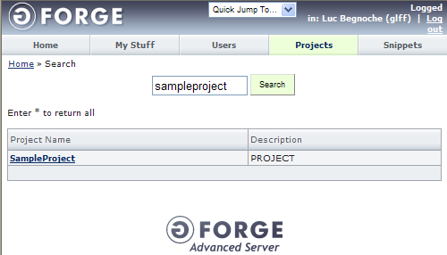

Once in the selected project view, click the “Admin” secondary tab.

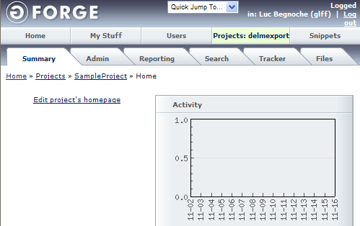

Once in the “Project/Admin” view, click the “Tracker/Admin” entry from the left menu.

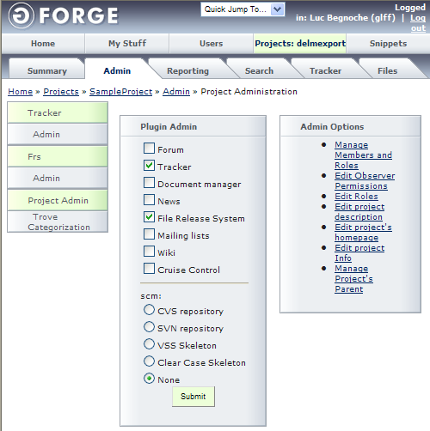

From the “Project/Tracker/Admin/Browse Tracker” view, it is possible to see all trackers available in the selected project. If the desired tracker exists, click it to select it. Else, click the “Add new Tracker” button to create the tracker. In this guide, it is assumed the tracker does not exist yet.

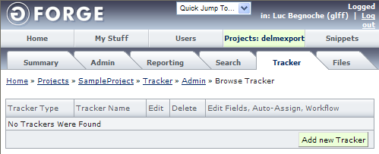

Once in the “Project/Tracker/Admin/Add new Tracker” view, enter the information for the new tracker.

A tracker is composed of the following items:
- A name (it is preferable to create a single tracker for issues called simply “Issues”)
- A description
- A set of permission (read the GForge user guide to know more about these)
- An email where all changes to the tracker are sent
- A due period (for a single tracker it is preferable to set a very long period to avoid seeing the tracker as late, for a tracker per iteration the due period shall be the iteration length)
- Instructions
- A tracker type (select “Issue Tracker” in this case)
- It is possible to clone another tracker (this will copy all the custom fields, see the next step for more information)

Once the correct information is entered, click the “Add” button.

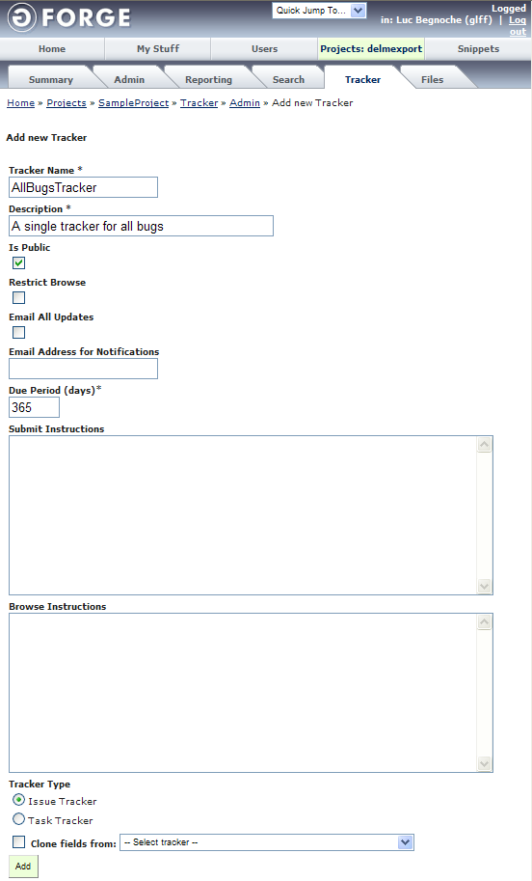

Back in the “Project/Tracker/Admin/Browse Tracker” view, the tracker will be displayed. Click the “Edit Fields, Auto-Assign, Workflow” statement beside the tracker for which custom fields must be created.

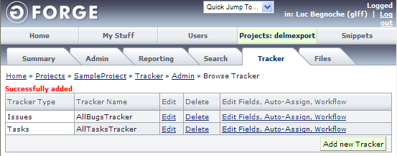

As described in the section entitled “Create a tracker for issues”, one extra field is necessary to establish traceability between software product versions and project issues:
- The target version in which the task must be performed

Follow the steps described in the section entitled “Create a tracker for issues” in order to create the necessary extra field.

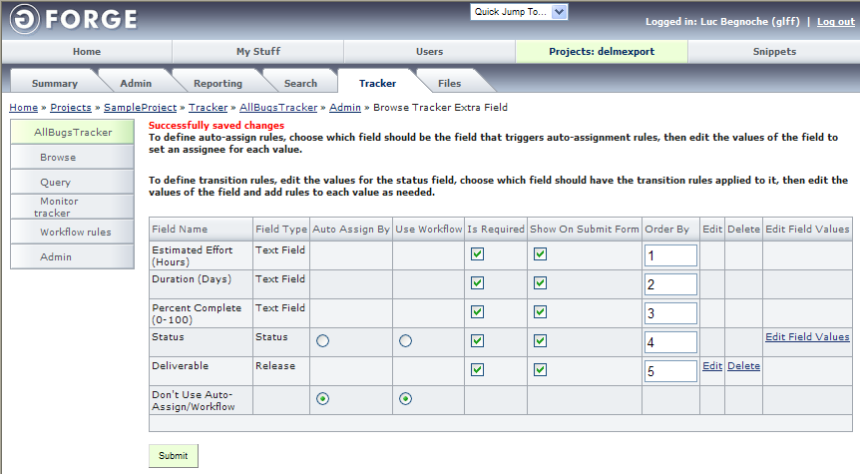

At this point the tracker may be used to create issues in the project.

Create an issue to track
Creating an issue in GForge helps to:
- Provide a list of problem/issues discovered during the execution of the project

Extra fields may be added to the tracker to help the project manager to:
- Document solutions to the issues
- Determine impact of solutions on the project plan

Outcomes
As a result of successful creation of an issue:

- A new issue tracking task is created in the GForge server.
- The issue tracking task is available for the assignee to see it in the “My Stuff” view.
- The issue tracking task is added to the project Gantt chart.

Step by step description
Login into GForge and enter the project in which the issue must be created. The project may be found using the “Projects” primary tab.

Once in the selected project view, click the “Tracker” secondary tab.

Once in the “Project/Tracker/Browse Tracker” view, click the name of the tracker in which the task must be created.

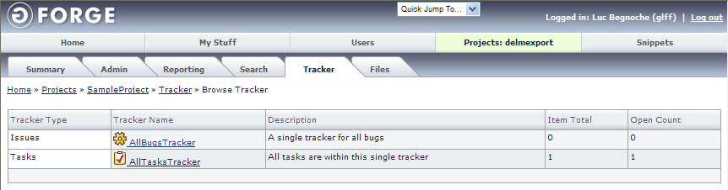

From the “Project/Tracker/Selected Tracker/Browse Tracker Item” view, it is possible to see all issues under the selected tracker (called tracker items in GForge). If the desired issue exists, click it to select it. Else click the “Add new Tracker Item” button to create the issue. In this guide, it is assumed the task does not exist yet.

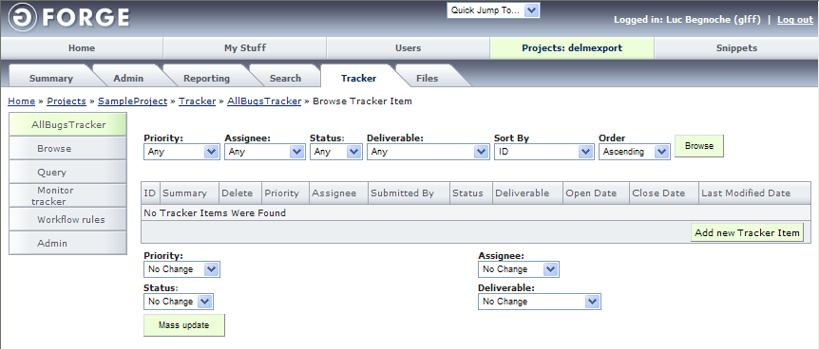

Once in the “Project/Tracker/Selected Tracker/Add new Tracker Item” view, enter the information for the new issue.

A issue tracking task is composed of the following fields as a minimum:
- Priority (a choice between: high, medium high, medium, medium low and low)
- Assignee (a choice between all the users assigned to the selected project)
- Status (this field should be set to open)
- Estimated effort (an estimation of effort in person/hours)
- Duration (this field is redundant since it could be automatically calculated from the start date and end date)
- Percent complete (this field should be set to zero)
- The target version in which the issue has been found
- Summary (a short description of the issue that is used as the issue name)
- Details (a detailed description of the issue)
- A list of files (any files useful for the issue)

To create this issue, click the “Add” button.

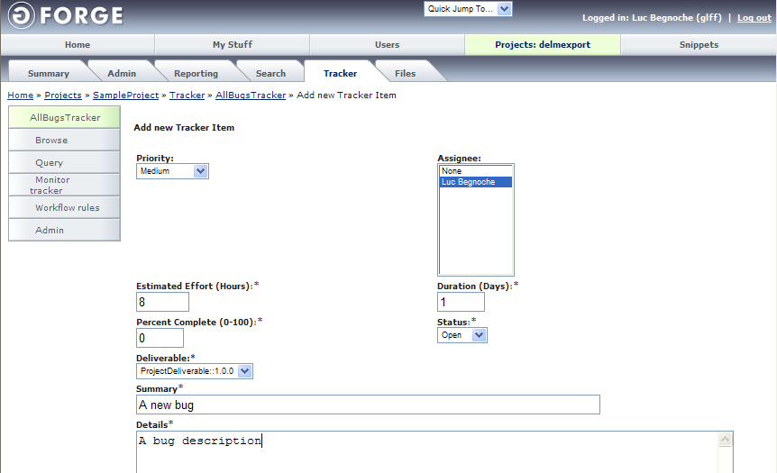
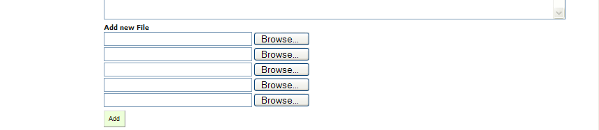

Back in the “Project/Tracker/Selected Tracker/Browse Tracker Item” view, the issue will be displayed.

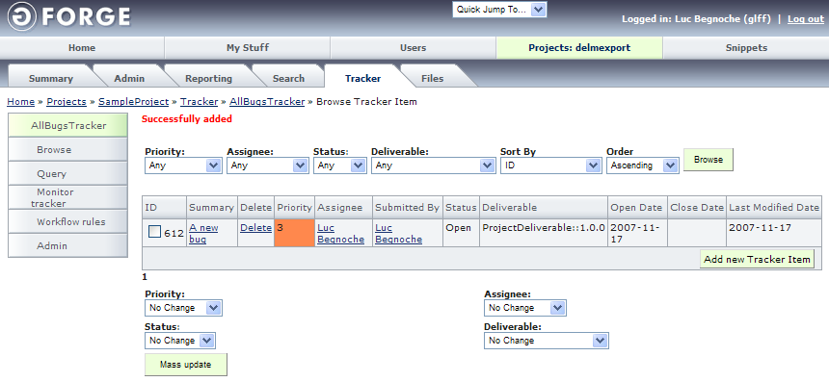

At this point the issue is recorded in the GForge server and can be updated by the assignee.

10. References to Other Standards and Models

This section provides references of this deployment package to ISO/IEC Standards and to the Capability Maturity Model IntegrationSM version 1.2 of the Software Engineering Institute (CMMI®).
Notes:
- This section is provided for information purpose only.
- Only tasks covered by this Deployment Package are listed in each table.
- The tables use the following convention:
- Full Coverage = F
- Partial Coverage = P
- No Coverage = N

This appendix shows the traceability of this deployment package to ISO/IEC standards and to the Capability Maturity Model IntegrationSM version 1.2 (CMMI®). For each element of the table coverage is indicated using the following convention:
- Full Coverage = F
- Partial Coverage = P
- No Coverage = N

Note: This appendix is provided for information purpose only.
Only tasks covered by this Deployment Package are listed in the matrices.

ISO/IEC29110-5-1 (Basic Profile) Reference Matrix

Title of the Task and Step | Coverage  Full/Partial | Clause of ISO/IEC29110-5-1
3.1.1 Track issues | Full | PM.2.4 Conduct revision meetings with the Work Team, record agreements and track them to closure.  PM.2.5 Conduct revision meetings with the Customer, record agreements and track them to closure.  PM.3.2 Establish actions to correct deviations or problems concerning the accomplishment of the plan, as needed, document them in Corrective Actions Register and track them to closure.

ISO/IEC 12207 Reference Matrix

Title of the Task and Step | Coverage  Full/Partial | Clause of ISO/IEC 12207
3.1.1 Track issues | Full | 6.3.2.3.2 Project control.  “The manager shall investigate, analyze, and resolve the problems discovered during the execution of the project.”

CMMI Reference Matrix

Title of the Task and Step | Coverage  Full/Partial | Goal/Practice of CMMI V1.2
3.1.1 Track issues | Full | Project Monitoring and Control  SP 1.6 Conduct Progress Reviews  “Periodically review the project's progress, performance, and issues.”  SP 2.1 Analyze Issues  “Collect and analyze the issues and determine the corrective actions necessary to address the issues.”  SP 2.2 Take Corrective Action  “Take corrective action on identified issues.”  SP 2.3 Manage Corrective Action  “Manage corrective actions to closure.”

11. References

Key | Reference
[ISO/IEC 12207] | ISO/IEC 12207:2008 Systems and software engineering - Software life cycle processes.
[ISO/IEC 24765] | ISO/IEC 24765, Systems and Software Engineering Vocabulary.
[ISO/IEC 29110] | Software Engineering — Lifecycle Profiles for Very Small Entities (VSEs) — Part 5-1: Management and Engineering Guide - Basic VSE Profile
References

Key | Reference
[ISO/IEC29110-5-1] | ISO/IEC ISP 29110-5-1, Software Engineering—Lifecycle Profiles for Very Small Entities (VSEs) – Part 5-1: Management and Engineering Guide – Basic Profile
[ISO/IEC12207] | ISO/IEC 12207:2008 Systems and software engineering - Software life cycle processes.
[ISO/IEC 24765] | ISO/IEC 24765, Systems and Software Engineering Vocabulary.
[CMU/SEI-2006-TR-008] | CMU/SEI-2006-TR-008 CMMI® for Development, Version 1.2, 2006.

12. Evaluation Form

Deployment Package – Issue Tracking with GForge version 0.2
Your feedback will allow us to improve this deployment package, your comments and suggestions are welcomed.
1. How satisfied are you with the CONTENT of this deployment package?
❑ Very Satisfied  Satisfied  Neither Satisfied nor Dissatisfied  Dissatisfied  Very Dissatisfied
2. The sequence in which the topics are discussed, are logical and easy to follow?
❑ Very Satisfied  Satisfied  Neither Satisfied nor Dissatisfied  Dissatisfied  Very Dissatisfied
3. How satisfied were you with the APPEARANCE/FORMAT of this deployment package?
❑ Very Satisfied  Satisfied  Neither Satisfied nor Dissatisfied  Dissatisfied  Very Dissatisfied
4. Have any unnecessary topics been included? (please describe)
5. What missing topic would you like to see in this package? (please describe)
- Proposed topic:
- Rationale for new topic
6. Any error in this deployment package?
  - Please indicate:
      - Description of error :
      - Location of error (section #, figure #, table #) :
7. Other feedback or comments:
8. Would you recommend this Deployment package to a colleague from another VSE?

❑ Definitely  Probably  Not Sure  Probably Not  Definitely Not
Optional
- Name:
- e-mail address : __________________________________

Email this form to: claude.y.laporte@etsmtl.ca or Avumex2003@yahoo.com.mx

Roles are defined in a next section. Roles are also defined in ISO/IEC 29110 Part 5-1
Roles are defined in a next section. Roles are also defined in ISO/IEC 29110 Part 5-1
SM CMM Integration is a service mark of Carnegie Mellon University. ® Capability Maturity Model, CMMI are registered in the U.S. Patent and Trademark Office by Carnegie Mellon University.
SM CMM Integration is a service mark of Carnegie Mellon University. ® Capability Maturity Model, CMMI are registered in the U.S. Patent and Trademark Office by Carnegie Mellon University.

