Deployment Package
Project Management with GForge

Notes:
This document is the intellectual propriety of its author’s organization. However, information contained in this document is free of use. The distribution of all or parts of this document is authorized for non commercial use as long as the following legal notice is mentioned:

© École de Technologie Supérieure

Commercial use of this document is strictly forbidden. This document is distributed in order to enhance exchange of technical and scientific information.
This material is furnished on an “as-is” basis. The author(s) make(s) no warranties of any kind, either expressed or implied, as to any matter including, but not limited to, warranty of fitness for purpose or merchantability, exclusivity, or results obtained from use of the material.
The processes described in this Deployment Package are not intended to preclude or discourage the use of additional processes that Very Small Entities may find useful.

Author | L. BEGNOCHE, École de Technologie Supérieure (ETS), Canada
Editors | C. Y. LAPORTE, École de Technologie Supérieure  ANA VAZQUEZ – 5th level, (México)
Creation date | 10/03/2008
Status | Draft
Version | 0.2

Versions

Date  (yyyy-mm-dd) | Version | Auteur | Modification
2008-10-30 | 0.1 | L. Begnoche | Document creation
2009-07-31 | 0.2 | C.Y. Laporte | Overall edition, update to new template

Abbreviations/Acronyms

Abre./Acro. | Definition
DP | Deployment Package - a set of artefacts developed to facilitate the implementation of a set of practices, of the selected framework, in a Very Small Entity.
VSE | Very Small Entity – Enterprise, department or project with a total staff of a maximum of 25 people.
VSEs | Very Small Entities
PM | Project Management

Table of Contents

1. Technical Description 4
Purpose of this document 4
Why Project Management is Important ? 4
2. Definitions 5
Generic Terms 5
Specific Terms 5
3. Relationships with ISO/IEC 29110 6
4. Description of Processes, Activities, Tasks, Steps, Roles and Products 7
Tasks 8
Document the project cycles and tasks 8
Document the resources 9
Document the work team composition and roles 10
Document the project estimated effort and cost 11
Document the risks 11
Verify, validate and correct the project plan 12
Execute the project plan 14
Evaluate progress against the project plan 14
Conduct meetings with the customer 15
Change the project plan according to the change requests 16
Formalize the completion of the cycle or project 16
Roles 18
Artefacts 18
5. Detailed Task Descriptions for GForge 21
GForge subtasks matrix 21
GForge subtasks description 22
Create a deliverable 22
Create a tracker for tasks 28
Create a task 36
Visualize the project plan (as a Gantt chart) 40
Browse assigned tasks 43
Update a task 44
Visualize project reports 46
Create a tracker for issues 49
Create an issue 55
6. References to Other Standards and Models 59
7. References 65
8. Evaluation Form 66

Technical Description

Purpose of this document

This Deployment Package (DP) supports the Basic Profile as defined in ISO/IEC 29110 Part 5-1: Management and Engineering Guide. A DP is a set of artefacts developed to facilitate the implementation of a set of practices in a Very Small Entity (VSE). A DP is not a process reference model (i.e. it is not prescriptive). The elements of a typical DP are: description of processes, activities, tasks, roles and products, template, checklist, example, reference and reference to standards and models, and tools

The purpose of this document, entitled “Deployment Package – Project Management with GForge” is to provide VSEs with a tailorable and easily usable guidelines to implement a project management process.

This document has been produced by Luc Begnoche a software engineering graduate student at ÉTS (École de Technologie Supérieure - www.etsmtl.ca).

Why Project Management is Important ?

Many software products fail not because there is no market, but because the cost of creating the software far outstrips any profit. Currently approximately half a million project managers worldwide are responsible for in the region of one million software projects each year, which produce software worth USD$600 billion. It is now accepted that many of these projects fail to fulfil customers' expectations or fail to deliver the software within budget and on schedule. [Putnam97] suggests that about one-third of projects have cost and schedule overruns of more than 125%.

Definitions
In this section, the reader will find two sets of definitions. The first set defines the terms used in all Deployment Packages, i.e. generic terms. The second set of terms used in this Deployment package, i.e. specific terms.

Generic Terms
Process: set of interrelated or interacting activities which transform inputs into outputs [ISO/IEC 12207].

Activity: a set of cohesive tasks of a process [ISO/IEC 12207].

Task: required, recommended, or permissible action, intended to contribute to the achievement of one or more outcomes of a process [ISO/IEC 12207].

Sub-Task: When a task is complex, it is divided into sub-tasks.

Step: In a deployment package, a task is decomposed in a sequence of steps.

Role: a defined function to be performed by a project team member, such as testing, filing, inspecting, coding. [ISO/IEC 24765]

Product: piece of information or deliverable that can be produced (not mandatory) by one or several tasks. (e. g. design document, source code).

Artefact: information, which is not listed in ISO/IEC 29110 Part 5, but can help a VSE during the execution of a project.

Specific Terms
Customer:
Organization or person that receives a product or service.
[ISO 12207:2008]

Project:
Endeavour with defined start and finish dates undertaken to create a product or service in accordance with specified resources and requirements.
[ISO 12207:2008]

Resource:
Asset that is utilized or consumed during the execution of a process.
[ISO 12207:2008]

Relationships with ISO/IEC 29110

This deployment package covers the activities related to project management of the ISO Technical Report ISO/IEC 29110 Part 5-1 for Very Small Entities (VSEs) – Basic Profile [ISO/IEC29110].

In this section, the reader will find a list of Project Management (PM) process, activities, tasks and roles. This topic is described in details in a section below.

- Process: <Number and Title>
- Activity: <Number and Title>
- Tasks and Roles:

Tasks | Roles
- <Number and Title> | Abbreviation

Description of Processes, Activities, Tasks, Steps, Roles and Products

Process: Number and Title
<details>

Activity: Number and Title
<details>

Tasks | Roles
Task Number and Title | Abbreviation

The tasks are:
- Document the project cycles and tasks
- Document the resources
- Document the work team composition and roles
- Document the project estimated effort and cost
- Document the risks
- Verify, validate and correct the project plan
- Execute the project plan
- Evaluate progress against the project plan
- Conduct meetings with the customer
- Change the project plan according to the change requests
- Formalize the completion of the cycle or project

Tasks

Document the project cycles and tasks

Objectives: | To establish estimates of the tasks and their duration supporting (or not) the feasibility of the project and its objectives.
Rationale: | Effective project planning is only possible through reliable estimates. Under-estimating a project will lead to a lack of staff and resources and will threaten the success of the project. On the other hand, over-estimating a project will lead to the use of unnecessary staff and resources and the project is most likely to cost more.
Roles: | Project Manager
Roles: | Technical Leader
Artefacts: | Statement of Work
Artefacts: | Project Plan
Steps: | - Review the Statement of Work
Steps: | - Identify the project lifecycle
Steps: | - Identify the specific tasks to be performed
Steps: | - Establish the Estimated Duration to perform each task
Steps: | - Generate a partial Project Plan
Step Description: | Step 1. Review the Statement of Work:  The project scope, objectives and deliverables and the product description defined in the statement of work shall be reviewed. The goal of this review is not to find defects but rather to get the necessary information to support the following steps. If some uncertainties arise during the review, they should be discussed with the customer.  Step 2. Identify the project lifecycle:  Based on the project scope, objectives and deliverables and based on the product description, it is necessary to carefully choose a project lifecycle.  A project lifecycle may contain different phases depending on the technical needs to develop the product, such as the concept exploration by the creation of a proof of concept. The phases will influence the tasks to perform.  If the chosen project lifecycle is iterative, the cycles may need to be synchronized with the different deliverables contained in the statement of work. The cycles will influence the tasks to perform as well.  Step 3. Identify the specific tasks to be performed:  Based on the project deliverables, product description and chosen project lifecycle, it is necessary to identify the tasks to be performed. A popular practice to do so is to create a work breakdown structure. The work breakdown structure is a product-oriented tree-like structure where the top is organized around the product and its subcomponents and where the bottom is going toward specific tasks.  Step 4. Establish the Estimated Duration to perform each task:  For each task identified in the previous step, estimate the duration to perform it. The duration should be estimated in man/hours without consideration of the resource and staff needed to perform the task.  It may help to determine the size and complexity of the tasks prior to estimate them.  Step 5. Generate a partial Project Plan:  Document the project cycles and tasks in the project plan. The project plan is not complete yet but may be generated and used if needed.

Document the resources

Objectives: | To identify resources needed to perform the project tasks.
Rationale: | Without the necessary resources the project tasks cannot be performed and the project cannot be completed successfully.
Roles: | Project Manager
Roles: | Technical Leader
Artefacts: | Statement of Work
Artefacts: | Project Plan
Steps: | - Review the Statement of Work
Steps: | - Identify and document the resources
Steps: | - Generate the Project Plan
Step Description: | Step 1. Review the Statement of Work  The project scope, objectives and deliverables and the product description defined in the statement of work shall be reviewed. The goal of this review is not to find defects but rather to get the necessary information to support the following steps. If some uncertainties arise during the review, they should be discussed with the customer.  Step 2. Identify and document the resources  For each task identified in the project plan, identify the resources and quantities needed to perform the task. Resources can be labour, equipment, software applications, office space, etc.  Step 3. Generate a partial Project Plan  Document the resources in the project plan. The project plan is not complete yet but may be generated and used if needed.

Document the work team composition and roles

Objectives: | To establish the work team composition, to define the roles among the team and to assign project tasks to the work team members.
Rationale: | Without the necessary skills, roles and responsibilities the project tasks cannot be performed and the project cannot be completed successfully.
Roles: | Project Manager
Roles: | Technical Leader
Artefacts: | Statement of Work
Artefacts: | Project Plan
Steps: | - Review the Statement of Work
Steps: | - Establish the Composition of Work Team assigning roles and responsibilities
Steps: | - Generate the Project Plan
Step Description: | Step 1. Review the Statement of Work:  The project scope, objectives and deliverables and the product description defined in the statement of work shall be reviewed. The goal of this review is not to find defects but rather to get the necessary information to support the following steps. If some uncertainties arise during the review, they should be discussed with the customer.  Step 2. Establish the Composition of Work Team assigning roles and responsibilities:  Based on the identified tasks and resources, identify the required skills to perform the tasks and/or to work with the resources. And based on the estimated duration and the delivery dates, estimate the number of work team members with specific skills to execute the project. Compose a work team with roles and responsibilities.  For each task identified in the project plan so far, assign work team member(s).  Step 3. Generate a partial Project Plan:  Document the work team composition and roles in the project plan. The project plan is not complete yet but may be generated and used if needed.

Document the project estimated effort and cost

Objectives: | To establish the project budget and schedule.
Rationale: | The budget and schedule is essential for the management and control of the project.
Roles: | Project Manager
Roles: | Technical Leader
Artefacts: | Project Plan
Steps: | - Create the Schedule of the Project Tasks
Steps: | - Calculate and document the project Estimated Effort and Cost
Steps: | - Generate the Project Plan
Step Description: | Step 1. Create the Schedule of the Project Tasks  For each task identified in the project plan, assign estimated starting and end dates taking into account the estimated duration, required resources, required work team members and applicable dependencies. A popular practice is to begin by identifying major milestones imposed in the statement of work like deliverables.  Step 2. Calculate and document the project Estimated Effort and Cost  Using the schedule of the project tasks and the required resources, calculate the estimated effort and cost.  Step 3. Generate a partial Project Plan  Document the work team composition and roles in the project plan. The project plan is not complete yet but may be generated and used if needed.

Document the risks

Objectives: | To identify and document the risks which may affect the project.
Rationale: | In a project plan many assumptions are made and some of them are wrong. Since wrong assumptions may threaten the project execution it is important to identify them as risks and prepare actions to mitigate them just in case.
Roles: | Project Manager
Roles: | Technical Leader
Artefacts: | Project Plan
Steps: | - Identify the risks
Steps: | - Evaluate the risks impact and probability of occurrence
Steps: | - Prioritize the risks
Steps: | - Develop a risk mitigation plan for the most critical risks
Step Description: | Step 1. Identify the risks  Review the project plan and identify risks related to the project schedule, cost, required resources and work team. The risks should be any realistic and potential issues, threats or vulnerabilities that can negatively impact the project execution. The risks are often related to the assumptions that have been made while planning the project.  Step 2. Evaluate the risks impact and probability of occurrence  For each identified risk, evaluate the likelihood of this risk to occur and evaluate how much negative the effect would be on the project execution. Two distinct values must be recorded for each risk: the impact and the probability of occurrence. The evaluation should be done using a scale with three to five values. For instance, low, medium and high.  Step 3. Prioritize the risks  For each identified risk, assign a priority based on the impact and probability of occurrence. For instance, a simple formula could be to multiply the impact value and the probability of occurrence value. The priority should be assigned using a scale with three to five values.  Step 4. Develop a risk mitigation plan for the most critical risks  For each identified risk having a high priority, it is necessary to develop and document a mitigation plan. A risk mitigation plan is a series of actions planned to avoid, reduce, and control the probability of occurrence and/or the impact of the risk. The developed mitigation plans should be documented in the project plan.

Verify, validate and correct the project plan

Objectives: | To ensure the project plan meets the standard requirements of any project plan. To ensure the project plan is in accordance with the scope, objectives, product description and deliverables documented in the statement of work. To obtain commitments and agreements from relevant stakeholders.
Rationale: | Since the project plan will be used throughout the project to monitor and control its execution, it is important to evaluate the quality of the project plan and to correct the project plan if the quality is not sufficient. It is also very important to validate the project plan fulfil the needs of the customer.
Roles: | Project Manager
Roles: | Technical Leader
Roles: | Customer
Artefacts: | Project Plan
Steps: | - Verify that all Project Plan elements are viable and consistent.
Steps: | - Correct the defects found in the Project Plan based on the Verification Results.
Steps: | - Validate that the Project Plan elements definition match with the Statement of Work.
Steps: | - Correct the defects found in the Project Plan based on the Validation Results.
Step Description: | Step 1. Verify that all Project Plan elements are viable and consistent  The project manager and the technical leader shall review the project plan and verify that all its elements are viable, consistent and that they fulfil the objectives of the tasks 3.1.1 to 3.1.5.  At the same time, the project manager shall obtain the commitment from the technical leader that the project can be executed within cost and schedule.  Step 2. Correct the defects found in the Project Plan based on the Verification Results  Every defects found during the previous step shall be corrected by following the instructions of the tasks 3.1.1 to 3.1.5.  Step 3. Validate that the Project Plan elements definition match with the Statement of Work  The project manager and the customer shall review the project plan and validate that its element match the scope, objectives, product description and deliverables documented in the statement of work.  At the same time, the project manager shall obtain the agreement from the customer that the work breakdown structure and major milestones (including deliverables) fulfil his needs.  Step 4. Correct the defects found in the Project Plan based on the Validation Results  Every defects found during the previous step shall be corrected by following the instructions of the tasks 3.1.1 to 3.1.5.  It may be necessary to iterate within this task until commitment from the technical leader and agreement from the customer are obtained.

Execute the project plan

Objectives: | To deploy staff and resources and to initiate the execution of the project plan.
Rationale: | It is essential to execute the project according to the plan.
Roles: | Project Manager
Roles: | Technical Leader
Roles: | Work Team
Artefacts: | Project Plan
Steps: | Not applicable
Step Description: | The execution of the project is based on the communication of the project plan to the technical leader and its work team:  - the assigned roles shall be communicated,  - the scheduled tasks shall be made available to the relevant work team members,  - the required resources shall be deployed,  - the actions to mitigate critical risks shall be performed.  The project plan is generally communicated through meetings or project management systems.

Evaluate progress against the project plan
Evaluate progress against the project plan
Objectives: | To track progress of the project execution and to take actions to correct deviations or problems concerning the accomplishment of the project plan.
Rationale: | No project plan is perfect and deviations from what have been planned will always occur. Therefore, it is necessary to identify the source of those deviations and improve the project plan accordingly to meet the major milestones and deliverables.
Roles: | Project Manager
Roles: | Technical Leader
Roles: | Work Team
Artefacts: | Project Plan
Artefacts: | Progress Status Record
Artefacts: | Corrective Actions Register
Artefacts: | Change Requests
Artefacts: | Meeting Support Record
Steps: | - Record actual data in Progress Status Record and evaluate project progress with respect to the project plan.
Steps: | - Identify correctives actions and changes to the project plan.
Step Description: | Step 1. Record actual data in Progress Status Record and evaluate project progress with respect to the project plan  By conducting meetings with the work team or by using project management systems, the project manager shall record the progress of the project execution.  Using the record and the project plan, the project manager shall compare:  - actual tasks progress against planned tasks  - actual results against established objectives  - actual resource allocation against planned resources  - actual cost against budget estimates  - actual risks against previously identified risks  Any deviation or problem concerning the accomplishment of the project plan shall be identified.  Step 2. Identify correctives actions, changes to the requirements and/or changes to the project plan  The project manager shall conduct meetings with the technical leader and the work team to identify correctives actions and changes to the project plan that are necessary to address identified deviations or problems. Those actions and changes shall be tracked to closure.

Conduct meetings with the customer

Objectives: | To inform the customer of the project progress and status. To obtain agreements on changes to the project plan that are necessary to address identified deviations or problems.
Rationale: | It is important to give to the customer a visibility on the project and to ensure all necessary changes still fulfil his needs.
Roles: | Project Manager
Roles: | Customer
Artefacts: | Project Plan
Artefacts: | Progress Status Record
Artefacts: | Corrective Actions Register
Artefacts: | Change Requests
Artefacts: | Meeting Support Record
Steps: | Not applicable
Step Description: | The project manager shall conduct regular meetings with the customer to communicate:  - the actual project progress and status,  - the identified deviations and problems,  - the corrective actions taken,  - the pending changes to the project plan.  The agreement for necessary changes shall be obtained. It is also during those meetings that the customer shall communicate any change request.

Change the project plan according to the change requests
Objectives: | To analyze and evaluate the Change Request for cost, schedule and technical impact, and include the approved changes in the Project Plan.
Rationale: | It is essential to change the project plan to address deviations and problems and to fulfil new customer needs.
Roles: | Project Manager
Roles: | Technical Leader
Artefacts: | Change Requests
Artefacts: | Project Plan
Steps: | Not applicable
Description: | To include a change request in the project plan it is necessary to perform the tasks 3.1.1 to 3.1.6 again.

Formalize the completion of the cycle or project

Objectives: | To get customer acceptance on the deliverable.
Rationale: | It is important at the end of a cycle or at the end of the project to get the customer acceptance over the product that has been delivered.
Roles: | Project Manager
Roles: | Customer
Artefacts: | Project Plan
Artefacts: | Acceptance Record
Steps: | Not applicable
Description: | A popular practice is to conduct acceptance testing with the customer, supporting them in this task with the technical leader and some members of the work team.  However, at the end, it is the project manager responsibility to get the acceptance record signed.

Roles

Role | Definition
Customer | Knowledge of the Customer processes and ability to explain the Customer requirements.  The Customer (representative) must have the authority to approve the requirements and their changes.
Project Manager | Leadership capability with experience making decisions, planning, personnel management, delegation and supervision, finances and software development.
Technical Leader | Knowledge and experience in the software development and maintenance.
Table 1 Definitions of Roles

Artefacts
Artefacts | Definition
Acceptance Record | Document establishing the customer acceptance of the deliverables of the project.  - Record of the receipt of the delivery  - Identifies the date received  - Identifies the delivered elements  - Records the verification of any Customer acceptance criteria defined  - Signed by receiving Customer
Change Request | It has the following characteristics:  - Identifies purpose of change  - Identifies request status (new, accepted, rejected)  - Identifies requester contact information  - Impacted system(s)  - Impact to operations of existing system(s) defined  - Impact to associated documentation defined  - Criticality of the request, date needed by
Corrective Actions Register | Actions established to correct a deviation or problem concerning the accomplishment of a plan.  - Identifies the initial problem  - Identifies the ownership for completion of defined action  - Defines a solution (series of actions to fix problem)  - Identifies the open date and target closure date  - Contains a status indicator  - Indicates follow up actions
Meeting Support Record | Record of the agreements established with Customer and Work Team. Agenda and minutes that records:  - purpose of meeting  - attendees  - date, place held  - reference to previous minutes  - what was accomplished  - identifies issues raised  - any open issues  - agreements  - next meeting, if any.  The applicable status is: updated.
Progress Status Record | Record of the status of the project against the Project Plan:  - status of actual tasks against planned tasks  - status of actual results against established objectives / goals  - status of actual resource allocation against planned resources  - status of actual cost against budget estimates  - status of actual time against planned schedule  - status of actual risk against previously identified  Record of any deviations from planned tasks and reason why.
Project Plan | Includes:  - Product Description  - Scope  - Objectives  - Deliverables  - Number of Cycles and Tasks, which includes verification, validation and reviews with Customer and Work Team, to assure the quality of work products. Tasks may be represented as a Work Breakdown Structure (WBS).  - Relationship and Dependence of the Tasks  - Estimated Duration of tasks  - Resources (humans, materials, equipment and tools) including the required training, and the schedule when the resources are needed.  - Composition of Work Team  - Schedule of the Project Tasks, the expected start and completion date, for each task.  - Estimated Effort and Cost  - Identification of Project Risks  - Version Control Strategy  - Product repository tools or mechanism identified  - Location and access mechanisms for the repository specified  - Version Control Strategy defined  - Backup and recovery mechanisms defined  - Storage, handling and delivery (including archival and retrieval) mechanisms specified  - Delivery Instructions  - Elements required for product release identified (i.e., hardware, software, documentation etc.)  - Delivery requirements  - Sequential ordering of tasks to be performed  - Applicable releases identified  - Identifies all delivered components with version information  - Identifies any necessary backup and recovery procedures  The applicable statuses are: verified, validated, baselined, changed and revised.
Statement of Work | Includes:  - Product Description  - Scope  - Objectives  - Deliverables  The applicable status is: revised
Table 2 Definitions of Artefacts

Detailed Task Descriptions for GForge

GForge subtasks matrix

Tasks | GForge subtask(s)
Document the project cycles and tasks | Create a deliverable  Create a tracker for tasks  Create a task
Document the resources | No GForge tasks are performed.
Document the work team composition and roles | Create a task  Browse assigned tasks  Update a task
Document the project estimated effort and cost | Visualize the project plan (as a Gantt chart)  Browse assigned tasks
Document the risks | No GForge tasks are performed.
Verify, validate and correct the project plan | No GForge tasks are performed.
Execute the project plan | Browse assigned tasks  Update a task
Evaluate progress against the project plan | Visualize the project plan (as a Gantt chart)  Browse assigned tasks  Visualize project reports  Create a tracker for issues  Create an issue
Conduct meetings with the customer | No GForge tasks are performed.
Change the project plan according to the change requests | See tasks 3.1.1 to 3.1.6.
Formalize the completion of the cycle or project | No GForge tasks are performed.

GForge subtasks description

Create a deliverable

Purpose

The purpose of creating a deliverable is to establish a version of a software product to which it is possible to bind tasks. Moreover, a deliverable may serve as a storage area where the software product can be uploaded and downloaded from GForge. This feature can be very useful for the configuration management process as well.

Outcomes

As a result of successful creation of a deliverable:

a) A new version of a software product is created in the GForge server.

Step by step

Login into GForge and enter the project in which the deliverable must be created. The project may be found using the “Projects” primary tab.

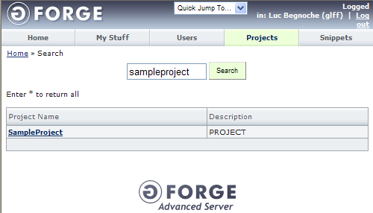

Once in the selected project view, click the “Files” secondary tab.

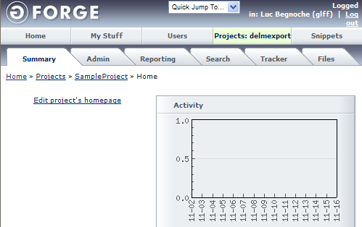

Once in the “Project/Files” view, click the “Admin” entry from the left menu.

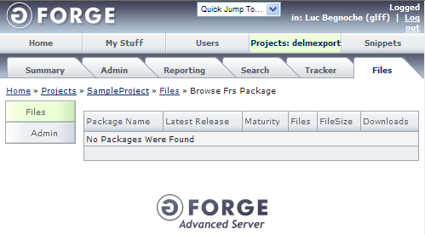

From the “Project/Files/Admin/Browse Frs Package” view, it is possible to see all software products available in the selected project (called packages in GForge). If the desired software product exists, click it to select it. Else, click the “Add new Frs Package” button to create the software product. In this guide, it is assumed the software product does not exist yet.

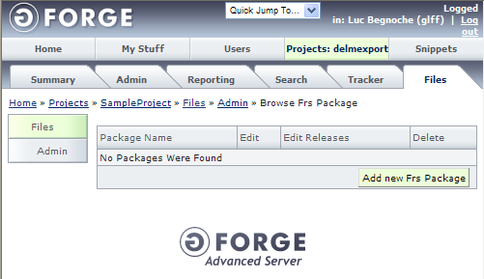

Once in the “Project/Files/Admin/Add new Frs Package” view, enter the information for the new software product.

A software product (called package in GForge) is composed of the following:
- A name (use the same name as in the configuration management system)
- A set of permissions (read the GForge user guide to know more about these)

Once the correct information is entered, click the “Add” button.

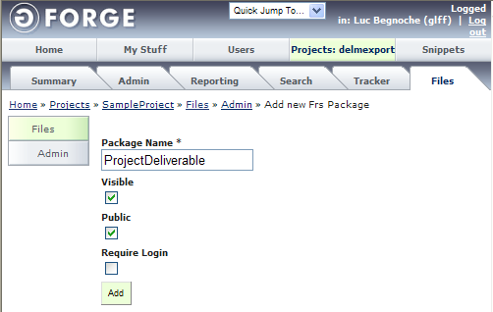

Back in the “Project/Files/Admin/Browse Frs Package” view, the software product will be displayed. Click the “Edit Releases” statement beside the software product for which the version must be created.

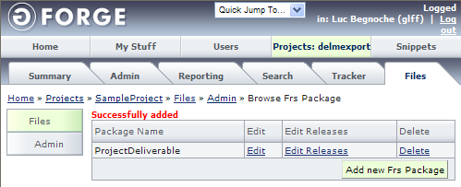

From the “Project/Files/Admin/Browse Frs Release” view, it is possible to see all versions available for the selected software product (called releases in GForge). If the desired version exists, click it to select it. Else click the “Add Release” button to create the version. In this guide, it is assumed the version does not exist yet.

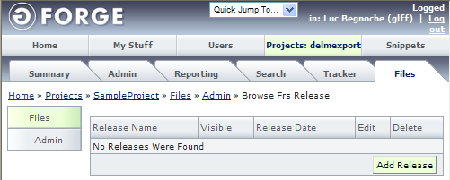

Once in the “Project/Files/Admin/Add Release” view, enter the information for the new version.

A version (called release in GForge) is composed of the following:
- A name (use the version number as in the configuration management system)
- A description (called release notes)
- A list of changes (to avoid manual synchronization coming with information redundancy, it is preferable to leave this field empty and to bind tasks to the version instead)
- A release date (once again, to avoid manual synchronization coming with information redundancy, it is preferable to ignore this field and to bind a delivery task to the version instead)
- A list of files (it is possible to upload the software product here if GForge is to be used as a configuration management system as well)

Once the correct information is entered, click the “Add” button.

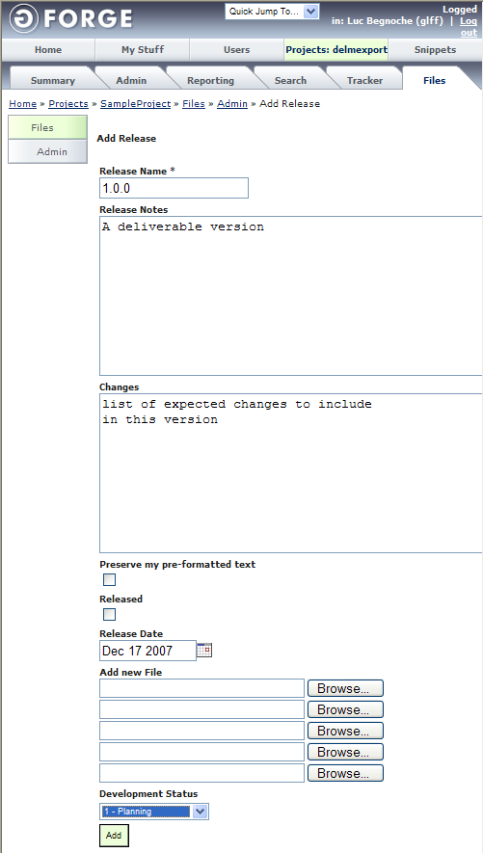

Back in the “Project/Files/Admin/Browse Frs Release” view, the version will be displayed.

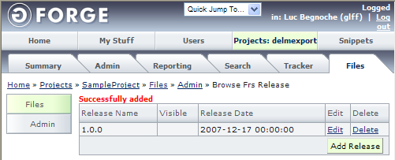

At this point the version and the software product may be used when tasks are created in the project.

Create a tracker for tasks

Purpose

The purpose of creating a tracker is to establish a storage area where tasks may be recorded.

This feature is not really useful from a project management point of view. However, in GForge, a tracker is necessary to be able to create any task. It is preferable to create only one tracker for each project since it is difficult to access the tasks from multiple trackers at the same time.

In the other hand, the tracker may be interesting if it is required to isolate multiple groups of tasks. For instance, it could be possible to track each iteration in the same project separately. But keep in mind that whenever it would be useful to access the tasks from multiple iterations at the same time, it will be nearly impossible.

Outcomes

As a result of successful creation of a tracker for tasks:

a) A new tracker is created in the GForge server.

Step by step

Login into GForge and enter the project in which the tracker must be created. The project may be found using the “Projects” primary tab.

Once in the selected project view, click the “Admin” secondary tab.

Once in the “Project/Admin” view, click the “Tracker/Admin” entry from the left menu.

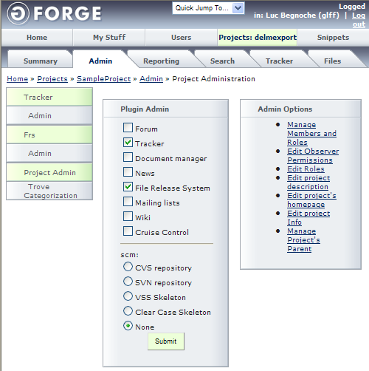

From the “Project/Tracker/Admin/Browse Tracker” view, it is possible to see all trackers available in the selected project. If the desired tracker exists, click it to select it. Else, click the “Add new Tracker” button to create the tracker. In this guide, it is assumed the tracker does not exist yet.

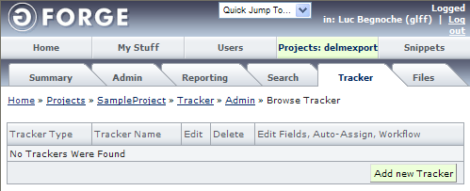

Once in the “Project/Tracker/Admin/Add new Tracker” view, enter the information for the new tracker.

A tracker is composed of the following:
- A name (it is preferable to create a single tracker for tasks called simply “Tasks”)
- A description
- A set of permission (read the GForge user guide to know more about these)
- An email where all changes to the tracker are sent
- A due period (for a single tracker it is preferable to set a very long period to avoid seeing the tracker as late, for a tracker per iteration the due period shall be the iteration length)
- Instructions
- A tracker type (select “Task Tracker” in this case)
- It is possible to clone another tracker (this will copy all the custom fields, see the next step for more information)

Once the correct information is entered, click the “Add” button.

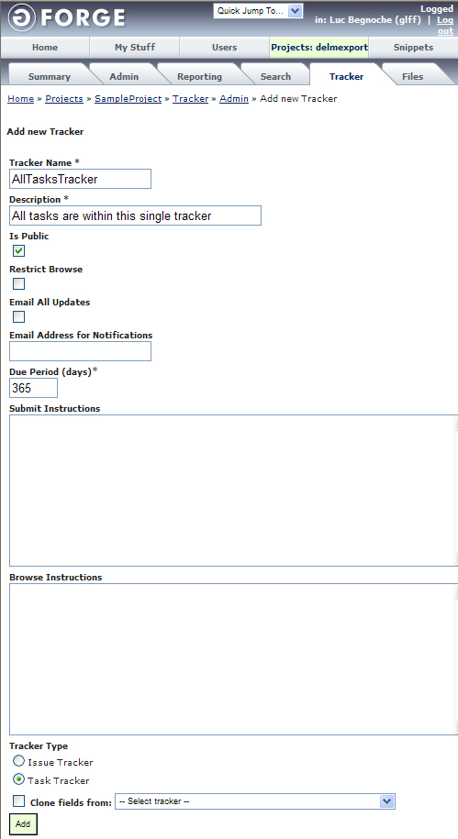

Back in the “Project/Tracker/Admin/Browse Tracker” view, the tracker will be displayed. Click the “Edit Fields, Auto-Assign, Workflow” statement beside the tracker for which custom fields must be created.

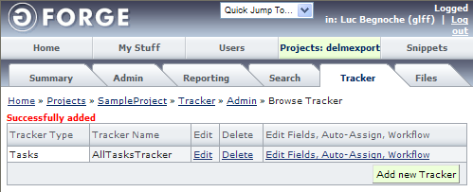

Once in the “Project/Tracker/Selected Tracker/Admin/Browse Tracker Extra Field” view, it is possible to see all fields available. These fields are used to describe each task that are to be created in the tracker.

Some fields are created by default and do not appear in the view (for more information on these fields see the next section “Create a task”):
- Start date
- End date
- Priority
- Assignee
- Summary
- Details
- A list of files

Some other fields are created by default and cannot be deleted from the view (for more information on these fields see the next section “Create a task”):
- Duration
- Percent complete
- Estimated effort
- Status (it is possible to edit the list of available status, at the end it all comes to “open” or “close” but it will be possible to sort the tasks by status)

Many other extra fields may be created. While it is a great feature to have the ability to define as many extra fields as wanted, this feature shall be used with care.

One extra field is necessary to establish traceability between the software product versions and project tasks:
- The target version in which the task must be performed

To create this field, click the “Add New FRS Release Field” statement.

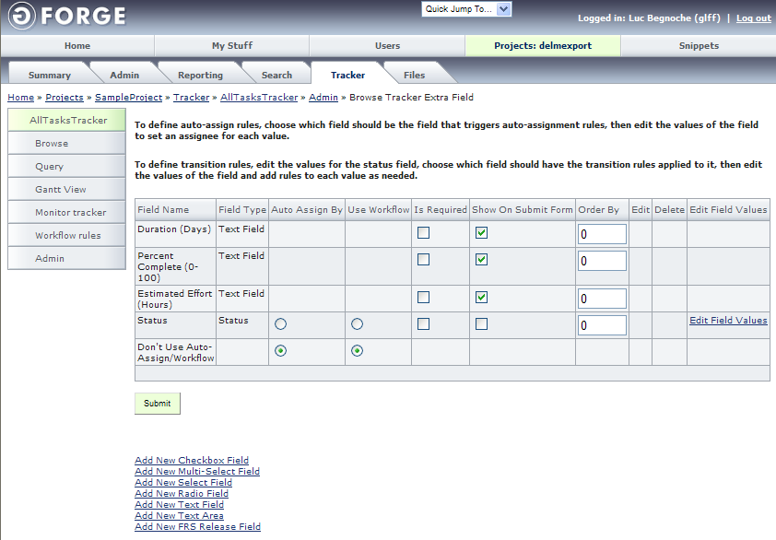

Once in the “Project/Tracker/Selected Tracker/Admin/Add new Tracker Extra Field” view, enter the information for the extra field:
- A name (“Deliverable” or any name that references the target version for a task)
- Select “Is Required” to ensure this field is never empty
- Select “Show On Browse” to ensure this field is displayed when the task are browsed
- Select “Show On Submit Form” to ensure this field is available when creating a task

Once the correct information is entered, click the “Add” button.

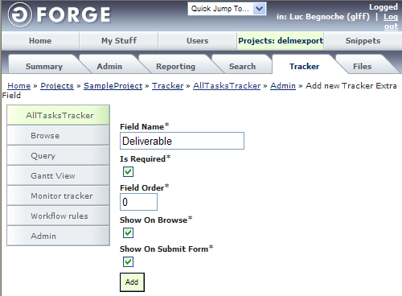

Once in the “Project/Tracker/Selected Tracker/Admin/Browse Tracker Extra Field” view, the extra field will be displayed.

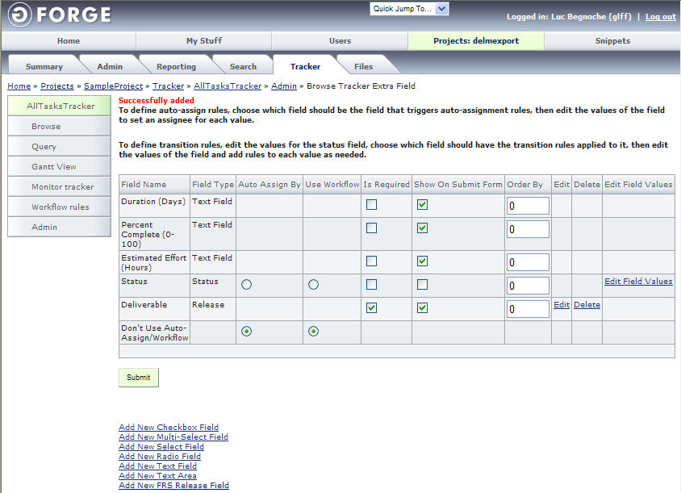

From this view, you can change some extra field options including the order. Click the “Submit” to apply any changes.

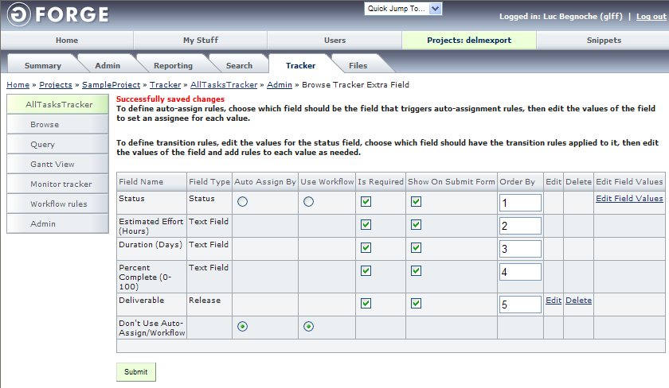

At this point the tracker may be used to create tasks in the project.

Create a task

Purposes

Creating a task in GForge has many purposes. It helps to:
- Schedule the project
- Estimate the effort
- Assign tasks to human resources

Extra fields may be added to the tracker to help the project manager to:
- Quantify the risk associated to every task
- Specify quality assurance measures to be employed
- Estimate the cost
- Provide environment and infrastructure

Outcomes

As a result of successful creation of a task:

- A new task is created in the GForge server.

- The task is available for the assignee to see it in the “My Stuff” view.

- The task is added to the project Gantt chart.

Step by step

Login into GForge and enter the project in which the task must be created. The project may be found using the “Projects” primary tab.

Once in the selected project view, click the “Tracker” secondary tab.

Once in the “Project/Tracker/Browse Tracker” view, click the name of the tracker in which the task must be created.

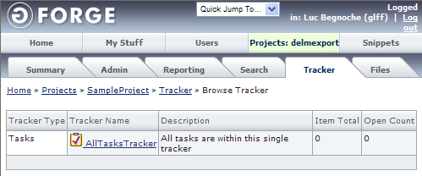

From the “Project/Tracker/Selected Tracker/Browse Tracker Item” view, it is possible to see all tasks under the selected tracker (called tracker items in GForge). If the desired task exists, click it to select it. Else click the “Add new Tracker Item” button to create the task. In this guide, it is assumed the task does not exist yet.

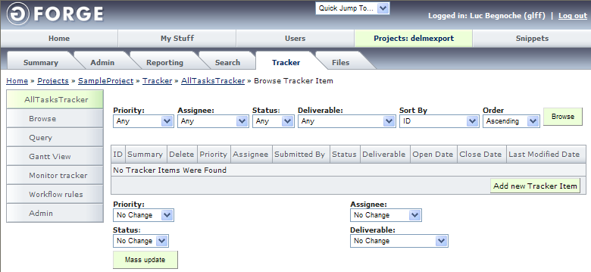

Once in the “Project/Tracker/Selected Tracker/Add new Tracker Item” view, enter the information for the new task.

A task shall be composed of the following fields as a minimum:
- Start date (the date the task is planned to be started, inclusive)
- End date (the date that task is planned to be finished, not inclusive)
- Priority (a choice between: high, medium high, medium, medium low and low)
- Assignee (a choice between all the users assigned to the selected project)
- Status (this field should be set to open)
- Estimated effort (an estimation of effort in person/hours)
- Duration (this field is redundant since it could be automatically calculated from the start date and end date)
- Percent complete (this field should be set to zero)
- The target version in which the task must be performed
- Summary (a short description of the task that is used as the task name)
- Details (a detailed description of the task)
- A list of files (any files useful for the task)

To create this task, click the “Add” button.

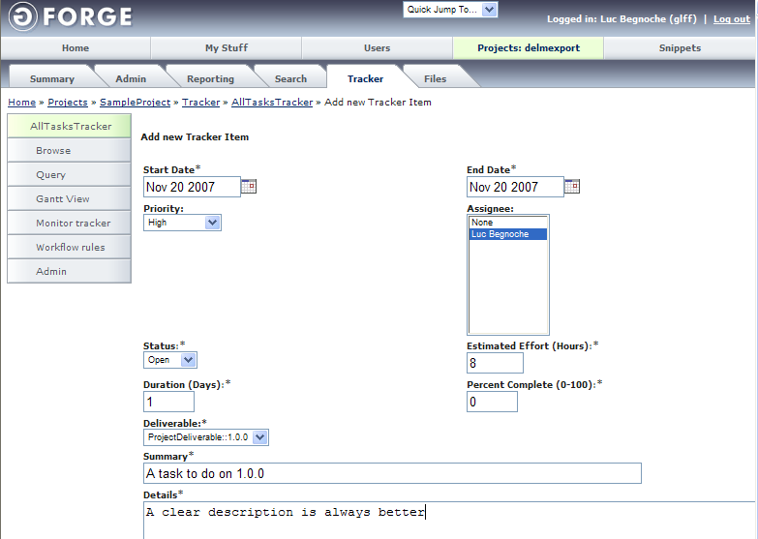
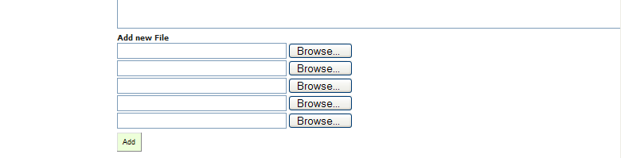

Back in the “Project/Tracker/Selected Tracker/Browse Tracker Item” view, the task will be displayed.

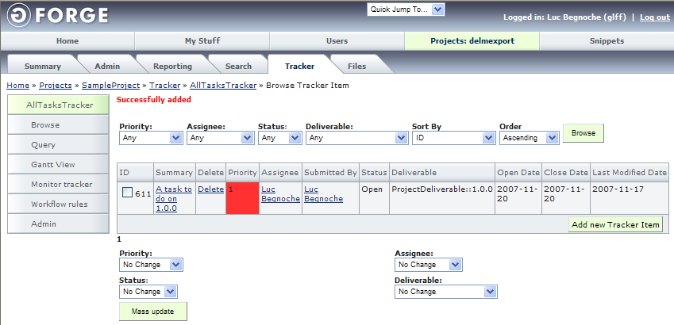

At this point the task is recorded in the GForge server and can be updated by the assignee.

Visualize the project plan (as a Gantt chart)

Purpose

Visualizing the project plan as a Gantt chart may be very useful to get a quick overview of the project planning.

Outcomes

As a result of successful visualization of the project plan:

- A Gantt chart is created.

Step by step

Login into GForge and enter the project for which the Gantt chart must be visualized. The project may be found using the “Projects” primary tab.

Once in the selected project view, click the “Tracker” secondary tab.

Once in the “Project/Tracker/Browse Tracker” view, click the name of the tracker for which the Gantt chart must be visualized.

From the “Project/Tracker/Selected Tracker/Browse Tracker Item” view, click the “Gantt View” entry in the left menu.

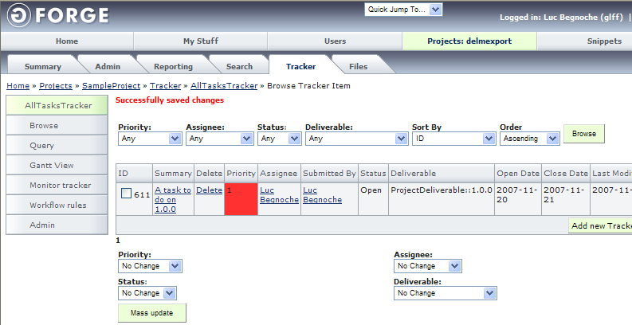

An image of the Gantt chart is displayed in a second window.

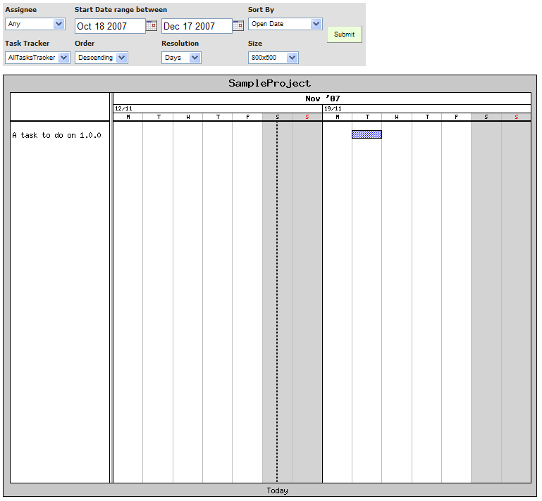

From there, it is possible to play with the multiple options to produce the desired Gantt chart.

Browse assigned tasks

Purpose

The purpose of browsing assigned tasks is for the assignees to know the tasks they have to execute.

Outcomes

This task does not have outcomes.

Step by step

Login into GForge and click the “My Stuff” primary tab.

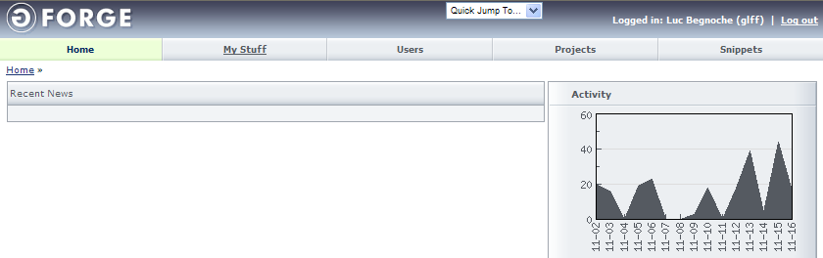

Once in the “My Stuff” view, it is possible for a project executor to see all tasks assigned to him. Move the cursor over a task name to see the detailed description appear in a tooltip.

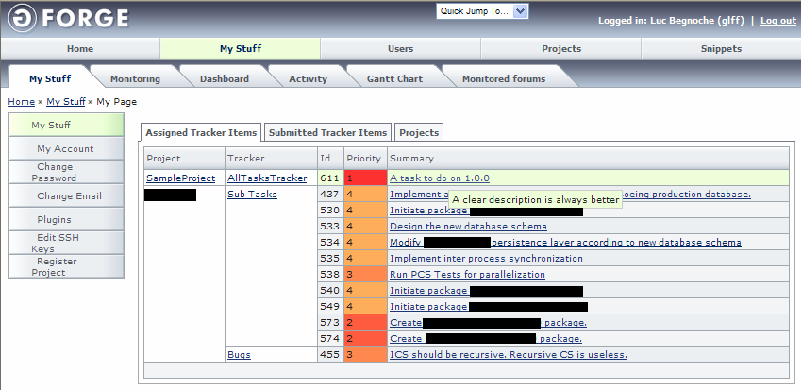

From here, it is possible to click any task name to update a task (see the next section).

Update a task

Purpose

The purpose of updating a task during the project execution is to help the project manager monitor the project. The project manager may use the internal reports offered by GForge at any time, given that the information in GForge is up-to-date.

Outcomes

As a result of successful update of a task:

- The task is modified in the GForge server.

- The task completion is shown in the project Gantt chart.

Step by step

From the “My Stuff” view (see the previous section), click the name of the task to update.

Once in the “Project/Tracker/Selected Tracker/Edit Tracker Item” view, enter the information for the new task.

An assignee shall only:
- Modify the percent complete
- Add comment

To update the task, click the “Save changes” button.

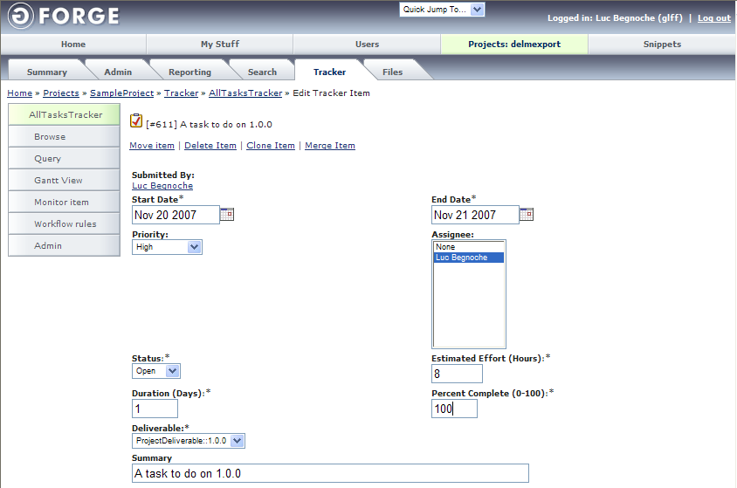
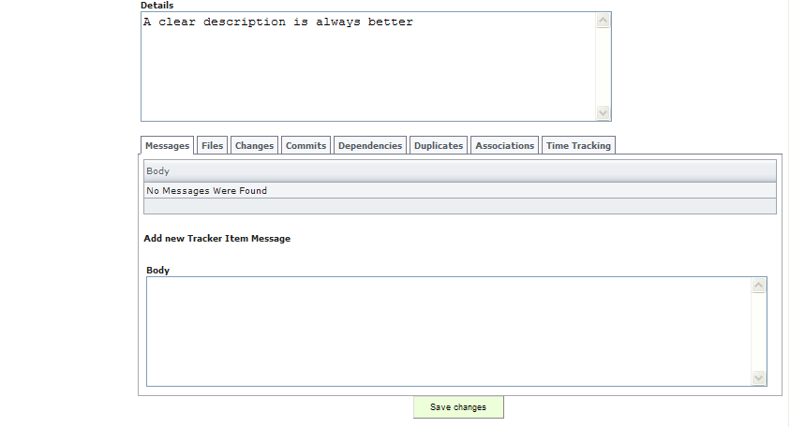

If the tasks are updated rigorously by the assignees, the project manager will be able to visualize reliable reports from GForge.

Visualize project reports

Purpose

The purpose of visualizing project reports is for the project manager to monitor the overall execution of the project. Many reports are provided by GForge in many views. In this guide, only two reports are described:
- Project plan (as a Gantt chart)
- Development roadmap

Outcomes

As a result of successful visualization of project reports:

a) Reports of the project progress are produced.

Step by step

By following the steps described in the section entitled “Visualize the project plan”, it is possible to get a Gantt chart that is updated with the percentage of completion of each tasks.

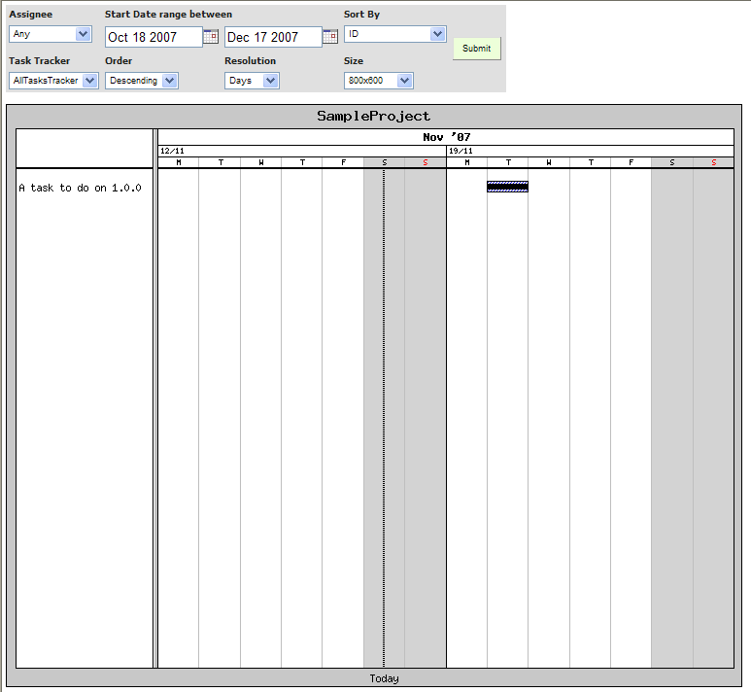

To visualize the development roadmap, do the following.

Login into GForge and enter the project for which the development roadmap must be visualized. The project may be found using the “Projects” primary tab.

Once in the selected project view, click the “Reporting” secondary tab.

The “Project/Reporting/Development Roadmap” view provides the project manager with a list of task and a progress bar for each software product version that is in development. Once a version is released, it disappears from this view.

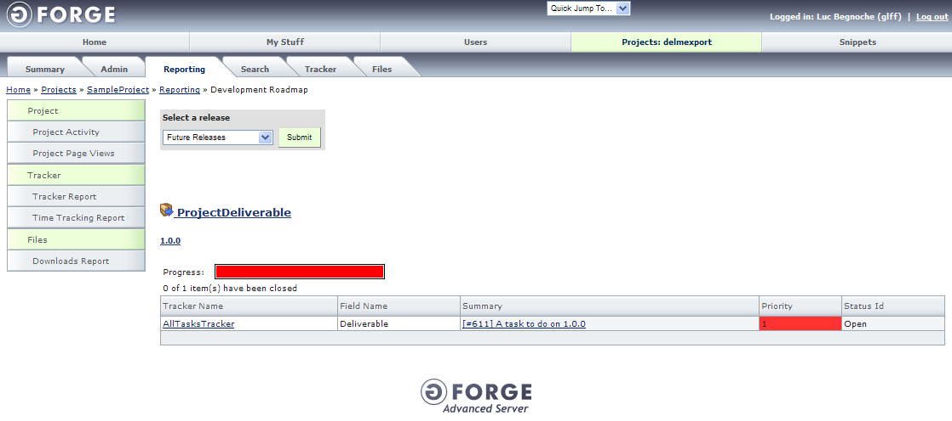

Create a tracker for issues

Purpose

The purpose of creating a tracker for issues is to establish a storage area where issues (bugs and problem encountered during development) may be recorded.

The difference between a tracker for issues and a tracker for tasks is that the issues are not shown in the project plan. Instead of the start date and the end date, there is an open date and a close date.

Outcomes

As a result of successful creation of a tracker for issues:

a) A new tracker is created in the GForge server.

Step by step

Login into GForge and enter the project in which the tracker must be created. The project may be found using the “Projects” primary tab.

Once in the selected project view, click the “Admin” secondary tab.

Once in the “Project/Admin” view, click the “Tracker/Admin” entry from the left menu.

From the “Project/Tracker/Admin/Browse Tracker” view, it is possible to see all trackers available in the selected project. If the desired tracker exists, click it to select it. Else, click the “Add new Tracker” button to create the tracker. In this guide, it is assumed the tracker does not exist yet.

Once in the “Project/Tracker/Admin/Add new Tracker” view, enter the information for the new tracker.

A tracker is composed of the following:
- A name (it is preferable to create a single tracker for issues called simply “Issues”)
- A description
- A set of permission (read the GForge user guide to know more about these)
- An email where all changes to the tracker are sent
- A due period (for a single tracker it is preferable to set a very long period to avoid seeing the tracker as late, for a tracker per iteration the due period shall be the iteration length)
- Instructions
- A tracker type (select “Issue Tracker” in this case)
- It is possible to clone another tracker (this will copy all the custom fields, see the next step for more information)

Once the correct information is entered, click the “Add” button.

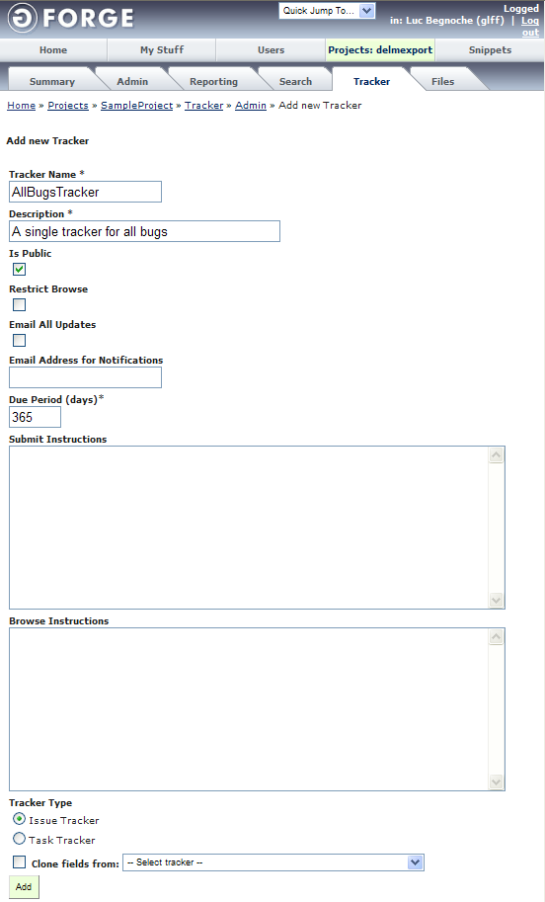

Back in the “Project/Tracker/Admin/Browse Tracker” view, the tracker will be displayed. Click the “Edit Fields, Auto-Assign, Workflow” statement beside the tracker for which custom fields must be created.

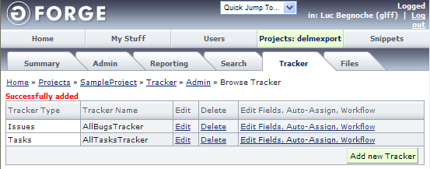

As described in the section entitled “Create a tracker for issues”, one extra field is necessary to establish traceability between software product versions and project issues:
- The target version in which the task must be performed

Follow the steps described in the section entitled “Create a tracker for issues” in order to create the necessary extra field.

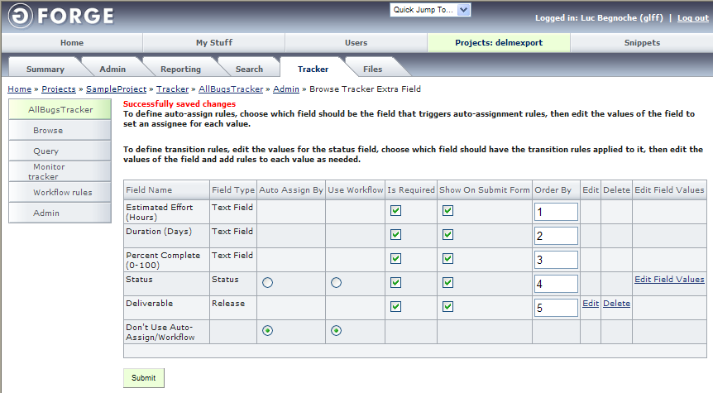

At this point the tracker may be used to create issues in the project.

Create an issue

Purpose

Creating an issue in GForge has many purposes. It helps to:
- Provide a list of problem discovered during the execution of the project

Extra fields may be added to the tracker to help the project manager to:
- Document solutions to the issues
- Determine impact of solutions on the project plan

Outcomes

As a result of successful creation of an issue:

- A new task is created in the GForge server.

- The task is available for the assignee to see it in the “My Stuff” view.

- The task is added to the project Gantt chart.

Step by step

Login into GForge and enter the project in which the issue must be created. The project may be found using the “Projects” primary tab.

Once in the selected project view, click the “Tracker” secondary tab.

Once in the “Project/Tracker/Browse Tracker” view, click the name of the tracker in which the task must be created.

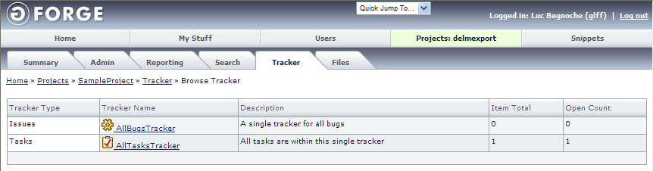

From the “Project/Tracker/Selected Tracker/Browse Tracker Item” view, it is possible to see all issues under the selected tracker (called tracker items in GForge). If the desired issue exists, click it to select it. Else click the “Add new Tracker Item” button to create the issue. In this guide, it is assumed the task does not exist yet.

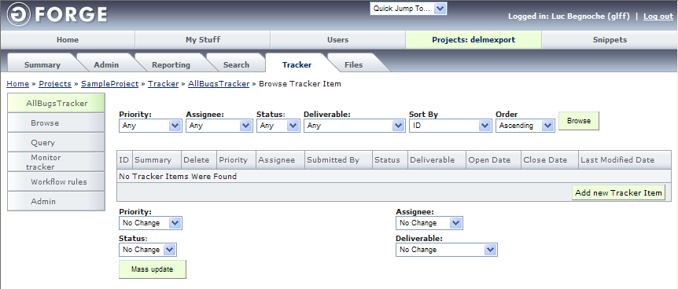

Once in the “Project/Tracker/Selected Tracker/Add new Tracker Item” view, enter the information for the new issue.

A task shall be composed of the following fields as a minimum:
- Priority (a choice between: high, medium high, medium, medium low and low)
- Assignee (a choice between all the users assigned to the selected project)
- Status (this field should be set to open)
- Estimated effort (an estimation of effort in person/hours)
- Duration (this field is redundant since it could be automatically calculated from the start date and end date)
- Percent complete (this field should be set to zero)
- The target version in which the issue has been found
- Summary (a short description of the issue that is used as the issue name)
- Details (a detailed description of the issue)
- A list of files (any files useful for the issue)

To create this issue, click the “Add” button.

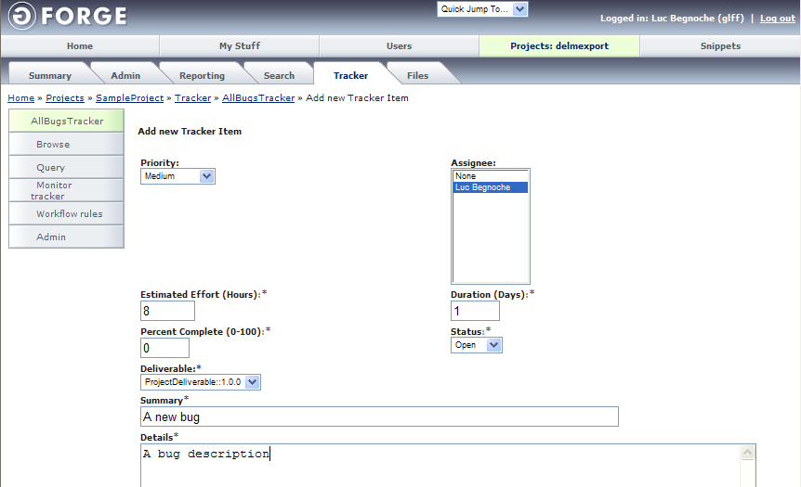
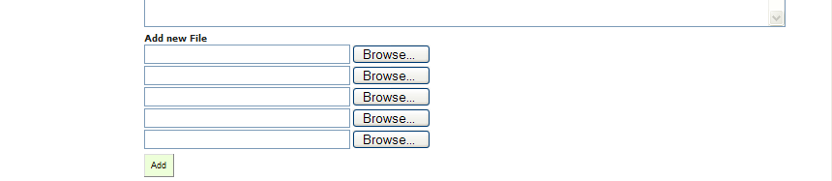

Back in the “Project/Tracker/Selected Tracker/Browse Tracker Item” view, the issue will be displayed.

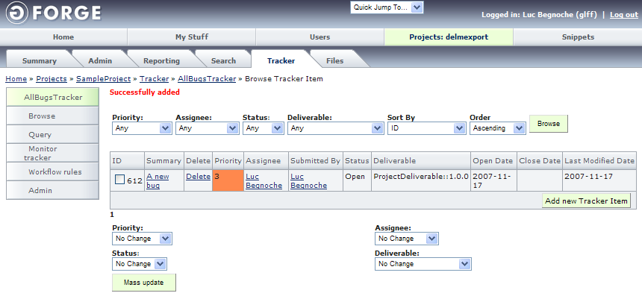

At this point the issue is recorded in the GForge server and can be updated by the assignee.

References to Other Standards and Models

This section provides references of this deployment package to ISO/IEC Standards and to the Capability Maturity Model IntegrationSM version 1.2 of the Software Engineering Institute (CMMI®).
Notes:
- This section is provided for information purpose only.
- Only tasks covered by this Deployment Package are listed in each table.
- The tables use the following convention:
- Full Coverage = F
- Partial Coverage = P
- No Coverage = N

ISO/IEC29110-5-1 (Basic Profile) Coverage Matrix

Title of the Task and Step | Coverage  Full/Partial | Clause of ISO/IEC29110-5-1
Document the project cycles and tasks | Full | PM.1.1 Review the Statement of Work.  PM.1.3 Identify the number of cycles and the specific tasks to be performed.  PM.1.4 Establish the Estimated Duration to perform each task.  PM.1.11 Generate the Project Plan.
Document the resources | Full | PM.1.1 Review the Statement of Work.  PM.1.5 Identify and document the resources.  PM.1.11 Generate the Project Plan.
Document the work team composition and roles | Full | PM.1.1 Review the Statement of Work.  PM.1.6 Establish the Composition of Work Team assigning roles and responsibilities.  PM.2.1 Agree with the Technical Leader on the tasks assignment for the Work Team.  PM.1.11 Generate the Project Plan.
Document the project estimated effort and cost | Full | PM.1.7 Assign estimated starting and end dates to each one of the tasks in order to create the Schedule of the Project Tasks.  PM.1.8 Calculate and document the project Estimated Effort and Cost.  PM.1.11 Generate the Project Plan.
Document the risks | Full | PM.1.9 Identify and document the risks which may affect the project.  PM.1.11 Generate the Project Plan.
Verify, validate and correct the project plan | Full | PM.1.13 Verify that all Project Plan elements are viable and consistent.  PM.1.14 Correct the defects found in the Project Plan based on the Verification Results.  PM.1.15 Validate that the Project Plan elements definition match with the Statement of Work.  PM.1.16 Correct the defects found in the Project Plan based on the Validation Results.
Execute the project plan | Full | PM.2.4 Conduct revision meetings with the Work Team, record agreements and track them to closure.
Evaluate progress against the project plan | Full | PM.2.2 Review the Project Plan and record actual data in Progress Status Record.  PM.2.4 Conduct revision meetings with the Work Team, record agreements and track them to closure.  PM.3.1 Evaluate project progress with respect to the Project Plan.  PM.3.2 Establish actions to correct deviations or problems concerning the accomplishment of the plan.  PM.3.3 Identify changes to requirements and/or Project Plan.
Conduct meetings with the customer | Full | PM.2.5 Conduct revision meetings with the Customer, record agreements and track them to closure.  PM.3.3 Identify changes to requirements and/or Project Plan.
Change the project plan according to the change requests | Full | PM.2.3 Record, analyze and evaluate the Change Request for cost, schedule and technical impact, and include the approved changes in the Project Plan.  PM.1.11 Generate the Project Plan.
Formalize the completion of the cycle or project | Full | PM.4.1. Formalize the completion of the cycle or project […] providing acceptance support and getting the Acceptance Record signed.

ISO/IEC 12207 Coverage Matrix

Title of the Task and Step | Coverage  Full/Partial | Clause of ISO/IEC 12207
Document the project cycles and tasks | Partial | 6.3.1.3.2 Project planning.  “The manager shall prepare the plans for execution of the project. […] These plans shall include, but are not limited to, the following:  a) Schedules for the timely completion of tasks.  b) Estimation of effort.  c) Adequate resources needed to execute the tasks.  d) Allocation of tasks.  e) Assignment of responsibilities.  f) Quantification of risks associated with the tasks or the process itself.  […]  h) Costs associated with the process execution.”
Document the resources | Partial
Document the work team composition and roles | Partial
Document the project estimated effort and cost | Partial
Document the risks | Partial
Verify, validate and correct the project plan | Partial | 6.3.1.3.2 Project planning.  6.3.1.3.3 Project activation.  “The manager shall obtain authorization for the project.”
Execute the project plan | Full | 6.3.1.3.3 Project activation.  “The manager shall initiate the implementation of the project plan/s to satisfy the objectives  and criteria set, exercising control over the project”
Evaluate progress against the project plan | Partial | 6.3.2.3.3 Project assessment.  “The manager shall assess the evaluation results of the software products, activities, and tasks completed during the execution of the project for achievement of the objectives and completion of the plans.”  6.3.2.3.2 Project control.  “The manager shall investigate, analyze, and resolve the problems discovered during the execution of the project.”
Conduct meetings with the customer | Partial | 6.3.2.3.1 Project monitoring.  “The manager shall monitor the overall execution of the project, providing both internal reporting of the project progress and external reporting to the acquirer as defined in the contract.”
Change the project plan according to the change requests | Partial | 6.3.2.3.2 Project control.  “The resolution of problems may result in changes to plans. It is the manager's responsibility to ensure the impact of any changes is determined, controlled, and monitored.”
Formalize the completion of the cycle or project | Full | 6.3.2.3.4 Project closure.  “When all software products, activities, and tasks are completed, the manager shall determine whether the project is complete, taking into account the criteria as specified in the contract or as part of organization's procedure.”

CMMI Coverage Matrix

Title of the Task and Step | Coverage  Full/Partial | Goal/Practice of CMMI V1.2
Document the project cycles and tasks | Full | Project Planning  SP 1.1 Estimate the Scope of the Project  “Establish a top-level work breakdown structure (WBS) to estimate the scope of the project.”  SP 1.2 Establish Estimates of Work Product and Task Attributes  “Establish and maintain estimates of the attributes of the work products and tasks.”  SP 1.3 Define Project Lifecycle  “Define the project lifecycle phases on which to scope the planning effort.”
Document the resources | Partial | Project Planning  SP 2.4 Plan for Project Resources  “Determine facilities, equipment, and component requirements.”
Document the work team composition and roles | Partial | Project Planning  SP 2.4 Plan for Project Resources  “Determine staffing requirements.”  SP 2.5 Plan for Needed Knowledge and Skills  “Staffing requirements are dependent on the knowledge and skills available to support the execution of the project.”
Document the project estimated effort and cost | Partial | Project Planning  SP 1.4 Determine Estimates of Effort and Cost  “Estimate the project effort and cost for the work products and tasks based on estimation rationale.”  SP 2.1 Establish the Budget and Schedule  “The project’s budget and schedule are based on the developed estimates and ensure that budget allocation, task complexity, and task dependencies are appropriately addressed.”
Document the risks | Full | Project Planning  SP 2.2 Identify Project Risks  “Risks are identified or discovered and analyzed to support project planning.”
Verify, validate and correct the project plan | Partial | Project Planning  SP 2.7 Establish the Project Plan  “A documented plan that addresses all relevant planning items is necessary to achieve the mutual understanding, commitment, and performance of individuals, groups, and organizations that must execute or support the plans.”  SP 3.2 Reconcile Work and Resource Levels  “To establish a project that is feasible, obtain commitment from relevant stakeholders and reconcile any differences between the estimates and the available resources.”  SP 3.3 Obtain Plan Commitment  “Obtaining commitment involves interaction among all relevant stakeholders both internal and external to the project.”
Execute the project plan
Evaluate progress against the project plan | Full | Project Monitoring and Control  SP 1.1 Monitor Project Planning Parameters  “Project planning parameters constitute typical indicators of project progress and performance and include attributes of work products and tasks, cost, effort, and schedule.”  SP 1.3 Monitor Project Risks  “Monitor risks against those identified in the project plan.”  SP 1.6 Conduct Progress Reviews  “Periodically review the project's progress, performance, and issues.”  SP 2.1 Analyze Issues  “Collect and analyze the issues and determine the corrective actions necessary to address the issues.”  SP 2.2 Take Corrective Action  “Take corrective action on identified issues.”  SP 2.3 Manage Corrective Action  “Manage corrective actions to closure.”
Conduct meetings with the customer | Full | Project Monitoring and Control  SP 1.6 Conduct Progress Reviews  “Periodically review the project's progress, performance, and issues.”  SP 1.7 Conduct Milestone Reviews  “Review the accomplishments and results of the project at selected project milestones.”
Change the project plan according to the change requests | Partial | Configuration Management  SP 2.1 Track Change Requests  “Change requests are analyzed to determine the impact that the change will have on the work product, related work products, budget, and schedule.”  Project Planning  See tasks 3.1.1 to 3.1.6.
Formalize the completion of the cycle or project | Full | Validation  SP 2.1 Perform Validation  “The as-run validation procedures should be documented and the deviations occurring during the execution should be noted, as appropriate.”  SP 2.2 Analyze Validation Results  “The data resulting from validation tests, inspections, demonstrations, or evaluations are analyzed against the defined validation criteria.”

References

Key | Reference
[ISO/IEC 12207] | ISO/IEC 12207:2008 Systems and software engineering - Software life cycle processes.
[ISO/IEC 24765] | ISO/IEC 24765, Systems and Software Engineering Vocabulary.
[ISO/IEC 29110] | Software Engineering — Lifecycle Profiles for Very Small Entities (VSEs) — Part 5-1: Management and Engineering Guide - Basic VSE Profile
[Putnam97] | Industrial Strength Software: Effective Management Using Measurement, L. H. Putnam and W. Myers, IEEE, 1997.

Evaluation Form

Deployment Package – Project Management with GForge– Version 0.2
Your feedback will allow us to improve this package, your comments and suggestions
are welcomed
1. How satisfied are you with the CONTENT of this deployment package?
❑ Very Satisfied  Satisfied  Neither Satisfied nor Dissatisfied  Dissatisfied  Very Dissatisfied
2. The sequence in which the topics are discussed, are logical and easy to follow?
❑ Very Satisfied  Satisfied  Neither Satisfied nor Dissatisfied  Dissatisfied  Very Dissatisfied
3. How satisfied were you with the APPEARANCE/FORMAT of this deployment package?
❑ Very Satisfied  Satisfied  Neither Satisfied nor Dissatisfied  Dissatisfied  Very Dissatisfied

4. Have any unnecessary topics been included? (please describe)

5. What missing topic would you like to see in this package? (please describe)

- Proposed topic:
- Rationale for new topic
- Any error in this deployment package?
  - Please indicate:
      - Description of error :
      - Location of error (section #, figure #, table #) :
7. Other feedback or comments:
8. Would you recommend this Deployment package to a colleague from another VSE?
❑ Definitely  Probably  Not Sure  Probably Not  Definitely Not
Optional
- Name:
- e-mail address : __________________________________

Email this form to : claude.y.laporte@etsmtl.ca or Avumex2003@yahoo.com.mx

Roles are defined in a next section. Roles are also defined in ISO/IEC 29110 Part 5-1
Roles are defined in a next section. Roles are also defined in ISO/IEC 29110 Part 5-1
SM CMM Integration is a service mark of Carnegie Mellon University. ® Capability Maturity Model, CMMI are registered in the U.S. Patent and Trademark Office by Carnegie Mellon University.

